Name __________________________________ # ______
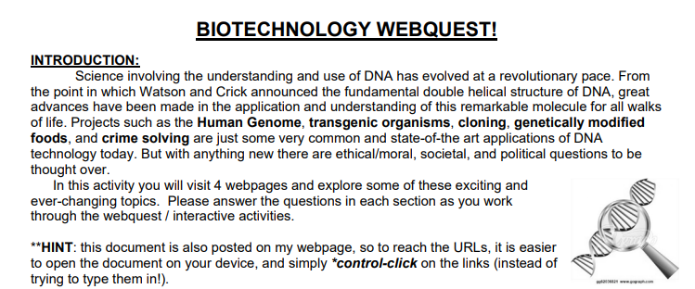

*You may OMIT Part A if you already understand electrophoresis (go to “B”)
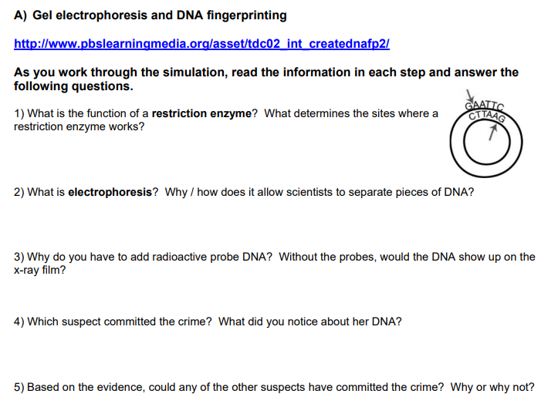

Use this link for part B: http://www.pbs.org/wgbh/harvest/engineer/
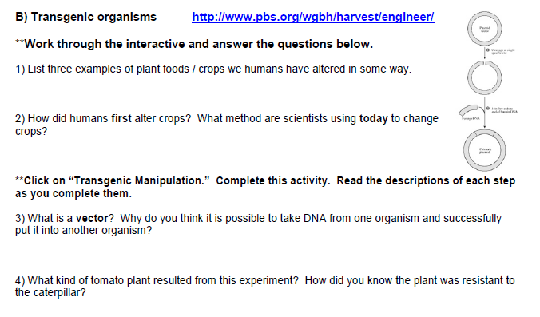
Use this link for part C: http://learn.genetics.utah.edu/
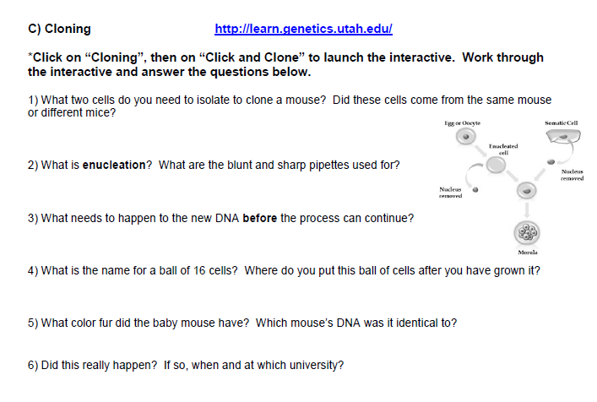
Use this site for Part D: https://learn.genetics.utah.edu/content/labs/pcr/
