AP Biology Exam Tips: Calculations, Grid-Ins and FRQs

Exam Location and Time: 2018- All AP Exams will be taken AT WHEELER (not Eastside). The AP Bio Exam begins at 8:00 AM on Monday, May 14. Report to your room (TBD) NO LATER than 7:45. If you are late, you WILL NOT be allowed to take the Exam.

What to Bring to the Exam: At least two #2 pencils (with good erasers); at least two black pens (FRQ must be answered in pen); 2 calculators (*see new policy below). NO PHONES or ‘Smart’ watches. Typically, there’s ~15 minutes between Section #1 (MC) and Section #2 (FRQ). Unless that policy has changed, you are allowed a restroom visit and a quick snack brought from home (I need to check that, though, as AP Exam Coordinator’s typically change from year to year). You may NOT discuss the Exam with ANYONE (or post anything on social media)!

A Reminder Regarding the Test Format:

The AP Biology Exam is approximately 3 hours in length. There are two sections.

- Section I is 90 minutes and consists of 63 multiple-choice questions and 6 grid-in questions, accounting for 50 percent of the final score.
- Section II is 90 minutes and consists of 2 long free-response questions and 6 short free-response questions accounting for 50 percent of the final score. It begins with a 10-minute reading period to read the questions and plan your answers. The remaining 80 minutes is for writing. The 2 long free-response questions should require about 20-21 minutes each to answer. Questions 3 through 8 are short free-response questions and should require about 6-7 minutes each to answer. Pay close attention to the ‘prompt’ words (ex- describe, propose, justify, etc.) and only do what the question requires. There’s no ‘extra credit’ here! Also, all responses MUST be in paragraph form, unless otherwise stated. You can make ‘diagrams’, but they must be within the context of your response.
  - MY ADVICE:
    - Do the 2 long free response questions FIRST (they count far more points), and then do the remaining 6 short FRQs in the order of your choosing (meaning…do the ones you know best first). Whatever you do, do not get ‘stuck’ on a question and waste valuable time!
    - There’s no guarantee your room will have a clock, so bring a watch and time yourself! (‘smart’ watches are not permitted)
    - Remember to only mark through any ‘mistake’ with 1 (or 2, max) ‘strikes’ with your pen.
    - If you are not 100% sure of the name of a process, we were told last year that you’d be better off to provide an accurate description of the process without the name, than an accurate description with the wrong name (they will deduct points for a wrong name).

Calculation Grid-In Tips:

- If a diagram is provided, analyze the diagram before you start calculating. You have to know what you are looking for!
- They won’t ask you for units in your answers on the calculation grid-in questions, but they may on the short / long free response questions. However, looking at the units may give you a hint as to which term in the equation you are being asked to find.
- Don’t round your work until you get to the answer!
- Read the directions carefully for each question you answer. The question will indicate whether you should round to the nearest whole number, tenth, hundredth, etc. If you round to a different place, your answer will be scored as INCORRECT!
- NEW in 2018- College Board has a new policy regarding approved calculators: “A four-function (with square root), scientific, or graphing calculator is permitted on both the multiple-choice and free-response sections of the AP Biology Exam since both sections contain questions that require data manipulation. Students may bring two permitted calculators to the exam. Calculators should be in good working order and may not be shared. Refer to our calculator policies for more information”. *Link gives a list of approved & unapproved calculators: https://apstudent.collegeboard.org/takingtheexam/exam-policies/calculator-policy
- You must be able to convert back and forth between scientific notation and whole numbers.
Examples:
- 5.1 X 10³ = 5100
- 6.2 X 10⁻⁴ = 0.00062
- 442 = 4.42 X 10²
- 0.008 = 8.0 X 10⁻³
- If you want to “get rid” of an exponent on the variable you are solving for, take each side of the equation to the power of the inverse of the exponent
Example: X^{1/3} = 5 can be adjusted to (X^{1/3})³ = (5)³ to isolate “X” and further simplified to X = 125

The “Grid-In Chart”
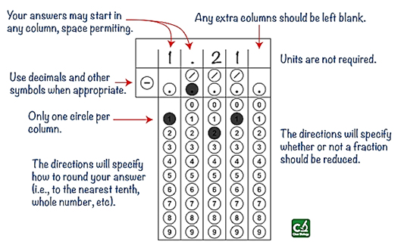

Acceptable Grid-In Responses:
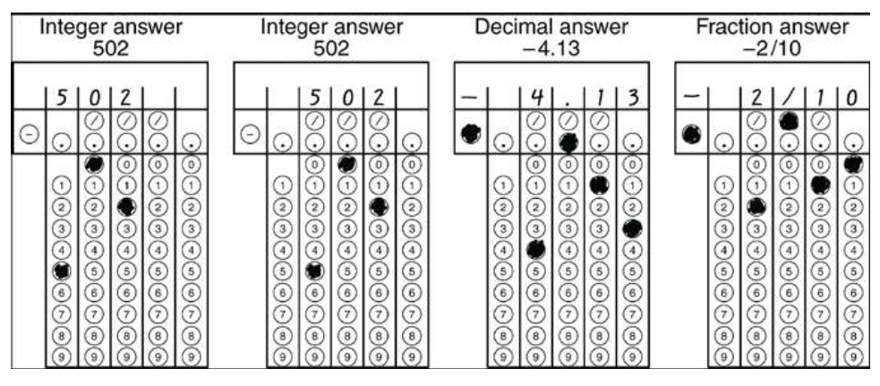

*One other piece of advice: The grid-in questions will be the last 6 questions of the Multiple Choice section (69 total questions in 90 minutes) of the AP Exam. You might want to consider doing those questions first. If you run out of time, you can’t ‘guess’ the grid-ins, but you could quickly bubble something in (answer choices A, B, C, D or E) for the multiple choice questions.

**Be sure to go over the AP Bio Formulas Sheet thoroughly. Be very familiar with where the equations are located on the sheet. Although they will provide you the sheet, don’t waste any time trying to find the correct formula. There is a link (right column) on my blog for the sheet.

