Case Study-Adventure in Stereochemistry Name _________________________ # _____

\****modified for distance learning in 2020***

**An Adventure in Stereochemistry**

**Frank J. Dinan and Gordon T. Yee**

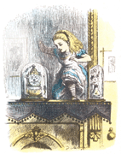*This case is based on an article that considered the problems that would arise if a person were to cross over into a mirror-image environment.*

***\*IMPORTANT******NOTE:*** *at this point, you are not expected to know the difference between R & S or D & L. The reason for the differentiation will be addressed later in this unit. For now, just know they are essentially “opposite”.*

**The Case Study**

The beautiful spring day made Alice reluctant to go into her dorm. She knew, though, that she had to study hard for her organic chemistry exam Professor Emil Fischer was giving the following day.

As she entered her room, she found her cat, Kitty, eagerly awaiting her arrival. Alice sighed. “I’m sorry, Kitty. I’d love to play with you, but I have to study for my stereochemistry test tomorrow.” Kitty tilted her head as if to say, “What’s that?” Alice smiled at the cat’s reaction, then settled into her favorite soft chair, opened her organic chemistry text, and began to read.

Alice’s stereochemistry reading went well for a while, but the hypnotic effect of the cat’s purring and the long day had their inevitable effect. The text began to blur, and Alice’s head nodded more and more frequently.

Alice found herself staring at her image in the full-length mirror hanging in her room. “We’re always talking about mirror images in my organic course, Kitty. I think that I’ll see what life is like on the other side of the mirror.” And with that, Alice stepped magically through the looking glass and entered Mirror Image Land.

“Who are you?” asked a startled old man wearing a rumpled tweed jacket.

“I’m Alice, from the other side of the mirror. Who are you?” asked Alice.

“I am Professor Rehcsif Lime, an organic chemist. May I ask why you came here?”

“I came here because I want to see what life is like in Mirror Image Land.”

“I see,” said the Professor. “I think that you will find that life is quite different here. Would you like a stick of sugar-free spearmint gum?”

“Why yes, thank you,” replied Alice. She unwrapped the gum and started to chew. “Bleeeech!” exclaimed Alice as she spit the gum out. “It tastes like sweet rye bread.”

“Yes, I thought that would be the case. You are not like us, you see,” said Professor Lime, grinning.

“What do you mean?” asked Alice, still trying to get rid of the terrible taste in her mouth.

“Well, the spearmint plant in your world makes *l*-carvone, which is associated with its smell and taste. But this is a mirror image world, and our spearmint plants make its mirror image, *d*-carvone. Because your taste buds and scent receptors are still the same, you perceive our spearmint gum to smell and taste like caraway, which is associated with d-carvone.”

“I still don’t understand,” said Alice. “Is everything going to be different on this side?”

“Well, no. Take baseballs, for instance. They’re the same in our world as in yours. But the gloves are different. The mirror image of a right-handed glove from your world doesn’t fit onto your right hand very comfortably. We say that balls are achiral, but gloves are chiral, that is, not superimposable on their mirror images. Of course, the mirror image of a right-handed glove fits your left hand perfectly.”

The Professor looked sad as he added, “You can’t stay here for long Alice or you’ll run into problems.”

“Problems? But why? I’m able to walk and breathe as if I were at home. Could I eat when I got hungry?”

“I’m afraid that would be the difficulty for you, Alice. All of your enzymes are mirror images of our enzymes, and yours aren’t adapted for digesting our food. Here, everything is the mirror image isomer, the enantiomer, of what exists in your world. Your enzymes won’t allow you to use any of our proteins, because our amino acids are mirror images of yours. Enzymes and the molecules that they act on have to fit together in a lock-and-key fashion for the enzymes to catalyze reactions. Your enzymes just aren’t arranged to process some of our molecules.”

“I study organic chemistry,” said Alice, “so I know that my enzymes only fit *l*-amino acids, but won’t they work with yours too?”

“No,” said Professor Lime. “Our amino acids are mirror images of yours. They are *d*-isomers, and that is all that my enzymes will digest. Here you could digest only one amino acid. It would be unlikely that you could derive nutritional value from any of the others.”

“Could I eat starches here?”

Professor Lime shook his head glumly. “No, you couldn’t. Think about what your starches are composed of compared to ours. Eating our starches wouldn’t help you. You’d soon starve.”

“Couldn’t I eat fats?”

“Excellent. You may have something there. You could eat some fats, but not others. You would have to be very careful just what fats you choose to eat or your enzymes will not be able to digest them. You would have to limit yourself to eating fats that are the same in both worlds.”

Alice was puzzled by Professor Lime’s comments. “Professor, this is giving me a terrible headache.”

“Oh dear, you must be careful what you take as a pain killer. Some that would help you in your world would not work here, and others would be effective both here and there. Also, the mirror images of some drugs that help in your world would be poisonous. You would have to choose very carefully.”

“But how can I know which ones will help me and which will not?”

Professor Lime furrowed his brow, thought for a moment, and then said, “Well, you can breathe the air here, can’t you?”

“Yes.”

“Well, there is your answer. Because our air works for you, you can use anything that is like our air.”

Alice’s headache grew steadily worse. She said, “But I can’t eat air. Whatever do you mean?”

“Of course you can’t eat air. I only meant that you could consume things that have the same characteristics as air. You can drink our water, for example.”

“Professor Lime, water isn’t like air. Water is a liquid and air is a gas. What do they have in common? What do you mean?”

Ignoring Alice’s question, the Professor continued, “Then, of course, vitamins would be a problem for you too. You could take some of ours, but others would do you no good.”

Her frustrations mounting, to say nothing of her headache, Alice said, “You’re right, Professor Lime. I enjoyed meeting you, but I’m afraid that life in Mirror Image Land is too much for me to handle. I’m going back through the mirror where things fit me better. Besides, I have to study for my stereochemistry test.”

“Goodbye, Alice. I enjoyed meeting you too. Good luck on your examination.”

With that, Alice found herself back in her room, with Kitty purring on her lap. She knew that she had been dreaming, but it all seemed so real. “You know, Kitty,” she said, “I guess I have been dreaming, but someone that I met in my dreams may have helped me to think about stereochemistry in a whole new way.”

**QUESTIONS**:

Professor Lime tells Alice that she could digest only one of the amino acids found in Mirror Image Land (MIL).

1. Which amino acid could Alice consume? _____________________________*\*Refer to the amino acid chart on p. 581 & 582 (also attached at end of this document)****.*** *R=Rest of molecule that makes each one different
2. Explain the reason for #1(in terms of chirality)

Professor Lime tells Alice that she could eat some MIL fats, but not others. Fats are formed from glycerol and various fatty acids *(*Fats/Lipids are in the PPt from Unit 4).* The general structure for glycerol is shown in Figure 1, below.

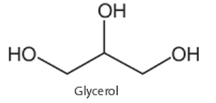

Fig 1:

1. Is glycerol chiral or achiral? _______________________.
   1. If it is chiral, circle the chiral carbon.
   2. Explain the reasoning for your answer:
2. Below, in Fig 2, is a monoglyceride. Is it chiral or achiral? ______________________

*\*R = the “Rest” of the molecule. It may be a H atom or 1 more C atoms.*

a.If it is chiral, circle the chiral carbon.

**Figure 2:**

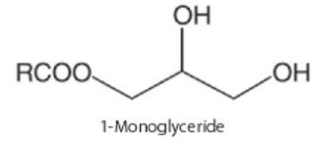

1. Below, in Fig 3, is a 1, 2 diglyceride.
   1. Assuming R and R’ are the same, is C #2 chiral or achiral? _______________
   2. Assuming R and R’ are different, is C #2 chiral or achiral? _______________
   3. Explain your reasoning: \**Be careful with this one. Might want to draw in the carbons and hydrogens.* *Also, refer to p. 427 of text*

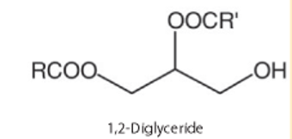

Fig 3

1. The structure of carvone is shown in Figure 2, but its stereochemistry is not specified. Literature sources (Budavari 1996) indicate that*l*-carvone (the R-isomer) smells like spearmint, and *d*-carvone (the S-isomer) smells like caraway. There is only one chiral carbon in carvone. **Circle which carbon is chiral**.

*\*Remember, a chiral carbon must have 4 different substituents bonded to it, therefore****, a carbon with a double bond directly attached to it is NOT chiral.***

*\*\*You will learn the R, S designation in the next assignment. For now, only know they are enantiomers and not “which is which”.*



1. Draw the structure of the other carvone enantiomer to the right of the figure. *\*Refer to p. 424 and 425 from your text for how to draw mirror images correctly. Also refer to Exp 15.1*
2. Professor Lime cautions Alice that she must be careful what pain reliever she chooses. Figure 3 shows the structures of four commonly used analgesics. If we assume that only the mirror image isomers of these compounds were available to Alice in MIL, which of these compounds would be good choices for Alice to take? ________________________________

*\*HINT- only one of these has NO chiral carbons in their structure. The others have at least one. Refer to p. 427 for help.*

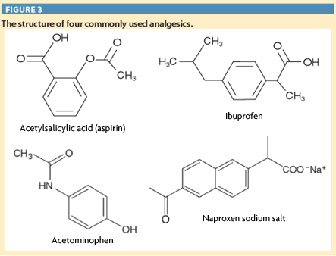

1. Alice is confused when Professor Lime tells her that because she can breathe in MIL she can eat anything that is “like our air.” He also includes water in the things that Alice could use safely in MIL. Explain the Professor’s reasoning when he made these statements to Alice.

**This is for EC only**, *This will become more evident in another day or 2, but why not give it a try?* The Professor cautions Alice that she would be able to use some MIL vitamins, but that others would not work for her. The structures of b-carotene and three important vitamins are shown in Figure 4.

Which of these could Alice use? _________________________________. Explain:

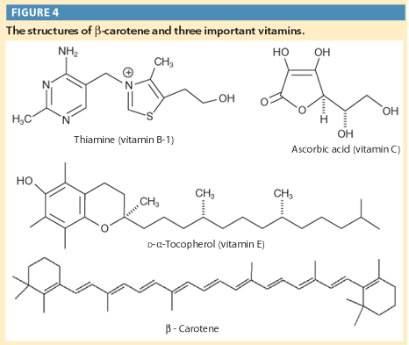

**Amino Acid Chart** *(*Jonathan…you owe me!):*

*R groups are highlighted

