- Define somatic –

- Define gametic –

Interphase

- What do cells do during interphase?

- What is the difference between chromatin and chromosomes?

  - Label the part of this diagram that shows DNA, histones, and a chromosome.

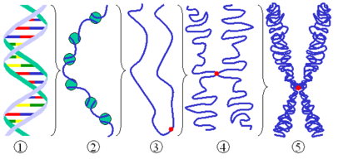

- How many chromosomes are in the human genome?

  - How many chromosomes come from each parent?

- How do cells in interphase look different than other stages?

  - Label the cell(s) in this picture that are in interphase.

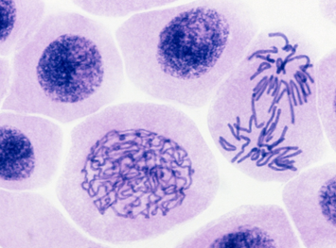

- Describe what occurs during each of these parts of interphase.

  - G1 –

  - S –

  - G2 –

Mitosis

- Define mitosis –

- What changes about cells in prophase?

  - Define chromatid –

  - Define centromere –

- Label the chromatid and centromere in this diagram.

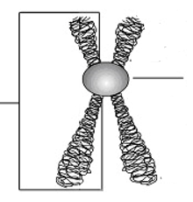

- What changes in cells during metaphase?

  - How do chromosomes move?

- What changes in cells during anaphase?

  - What are the now-separated chromatids called?

- What changes in cells during telophase?

- What changes in cells during cytokinesis?

- Explain how cytokinesis proceeds differently in animal and plant cells.

  - Animal Cells –

  - Plant Cells –

Cancer

- Do cells divide constantly?

- What are growth factors?

- Explain how each of these environmental factors can limit cell growth:

  - Density-dependent inhibition:

  - Anchorage dependence:

- What is the difference between a benign and a malignant tumor?

  - Benign –

  - Malignant –

Cell Division and Reproduction

- In multicellular organisms, mitosis is primarily for _________________________________.

- In unicellular organisms, mitosis is _____________________________________________.

- Define asexual reproduction –

  - What types of organisms rely on asexual reproduction?

- Define sexual reproduction –

  - What advantage do sexual reproducers have over asexual ones?

- Where do sperm begin?

- What are the end products of spermatogenesis?

  - What happens to each daughter cell?

- Define diploid (2n) –

Meiosis

- What are the end products of meiosis?

- Define haploid (n) –

- What is a tetrad?

  - What stage of meiosis do tetrads form?

  - Explain what occurs during crossing over at a tetrad.

- Label each phase of meiosis I and II in this diagram.

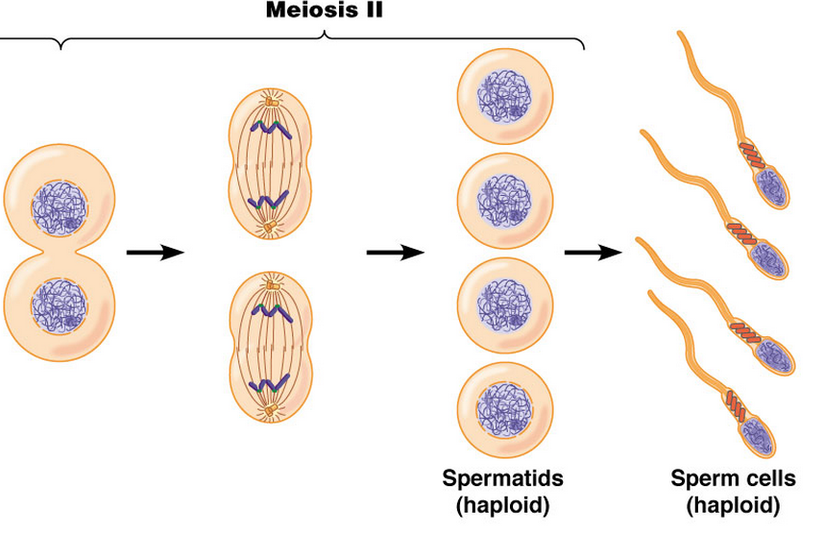
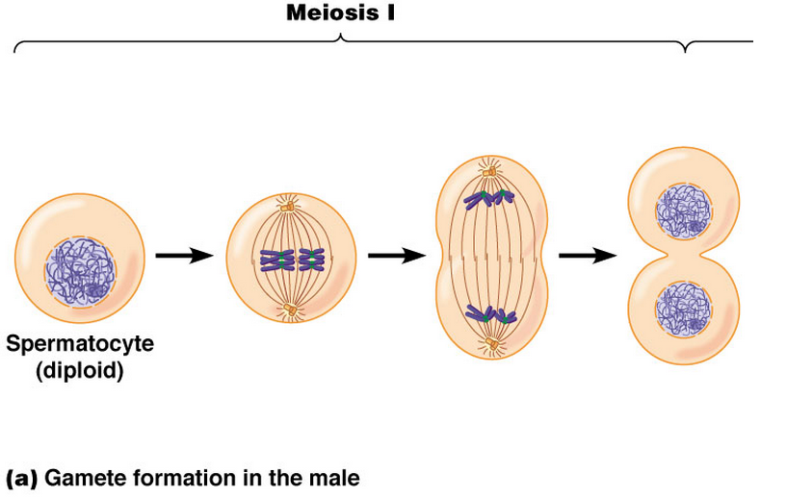

- How is meiosis different in oogenesis compared to spermatogenesis?

  - What is a polar body?

