Name ___________________________________ # _______
Chi-squared test practice problem ANSWER
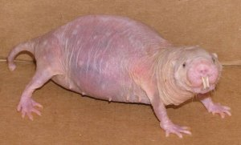
Naked mole rats are a burrowing rodent native to parts of East Africa. They have a complex social structure in which only one female (the queen) and one to three males reproduce, while the rest of the members of the colony function as workers. Mammal ecologists suspected that they had an unusual male to female ratio. They counted the numbers of each sex in one colony.
Sex | Number of animals
Female | 52
Male | 34

State the Null hypothesis

There is no difference in the numbers of male and female naked mole rats

Calculate the expected results
Expected results = 52 + 34 = 86 = 43
2 2
Calculate the chi-squared value
Sex | Observed | Expected | O - E | (O – E)² | (O – E)²/E
Female | 52 | 43 | 9 | 81 | 1.88
Male | 34 | 43 | 9 | 81 | 1.88
TOTAL |  |  |  |  | 3.76
² = 3.76
What are the degrees of freedom?
DF = n – 1 = 2 – 1 = 1

Compare the calculated value with the critical value
Degrees of freedom | Significance level
 | 0.05 (5%) | 0.02 (2%) | 0.01 (1%)
1 | 3.84 | 5.41 | 6.64
2 | 5.99 | 7.82 | 9.21

The critical value of Chi-squared at 5% significance (0.05) and 1 degree of freedom is 3.84
Our calculated value is 3.76
The calculated value is smaller than the critical value at the 5% (0.05) level of probability.
Make a conclusion
We fail to reject the null hypothesis. We cannot reject the null hypothesis, because there is not a significant difference between the observed and expected results at the 5% level of probability.
In doing this we are saying that the naked mole rates do not have a significantly larger female population in comparison with the male population and any differences among the populations were most likely due to chance.

