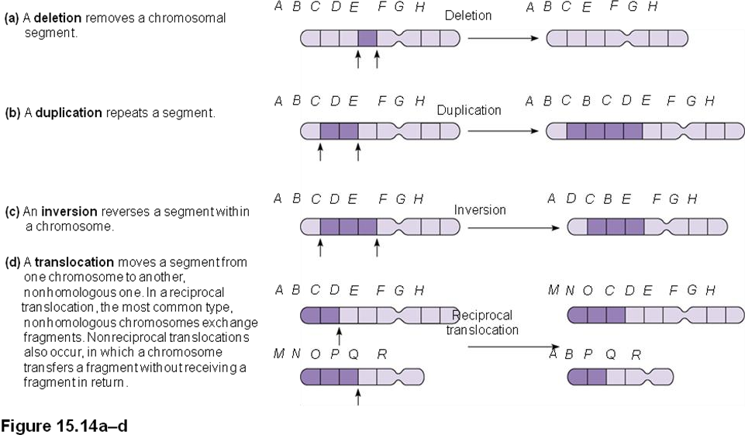**CHROMOSOMAL MUTATIONS** Name: ____________________________ #: __________

4.

3.

2.

1.

1. DELETION removes a chromosomal segment
2. TRANSLOCATION moves a segment from one

Chromosome to another, non-homologous one.

1. INVERSION reverses a segment within a chromosome
2. DUPLICATION repeats a segment

Match the description with the correct illustration of a chromosomal mutation:



a.

b.

c.

d.