Determining Amount of Excess Reactant:
Limiting Reactant - The reactant in a chemical reaction that limits the amount of product that can be formed. The reaction will stop when all of the limiting reactant is consumed.
Excess Reactant - The reactant in a chemical reaction that remains when a reaction stops when the limiting reactant is completely consumed. The excess reactant remains because there is nothing with which it can react.
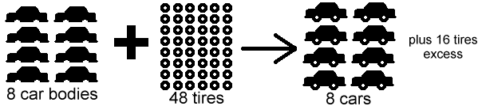
No matter how many tires there are, if there are only 8 car bodies, then only 8 cars can be made. Likewise with chemistry, if there is only a certain amount of one reactant available for a reaction, the reaction must stop when that reactant is consumed whether or not the other reactant has been used up.
Example Limiting Reactant Calculation:
A 2.00 g sample of ammonia is mixed with 4.00 g of oxygen. Which is the limiting reactant and how much excess reactant remains after the reaction has stopped?
First, we need to create a balanced equation for the reaction:
4 NH_{3(g)} + 5 O_{2(g)}4 NO_{(g)} + 6 H₂O_{(g)}
Next we can use stoichiometry to calculate how much product is produced by each reactant. NOTE: It does not matter which product is chosen, but the same product must be used for both reactants so that the amounts can be compared.
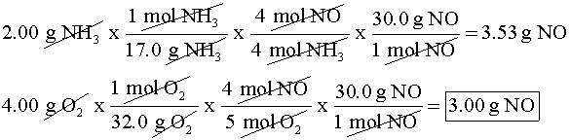
The reactant that produces the lesser amount of product in this case is the oxygen, which is thus the "limiting reactant."
Next, to find the amount of excess reactant, we must calculate how much of the non-limiting reactant (ammonia) actually did react with the limiting reactant (oxygen).
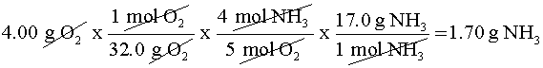
We're not finished yet though. 1.70 g is the amount of ammonia that reacted, not what is left over. To find the amount of excess reactant remaining, subtract the amount that reacted from the amount in the original sample.

