Ecosystem Relationships: Acorn Masting & Lyme Disease NAME__________________________ # ____
ANSWER ALL QUESTIONS THOROUGHLY. You may work in small groups for discussion, but answers MUST BE YOUR OWN. See the electronic copy on my blog to distinguish between the species (bar graphs).

Phenomenon
Many tree types including oak trees (genus Quercus) produce nutty fruits we know as acorns. Acorns are an important food resource for deer, rodents, wild pigs and insects. Oak trees have quiet years of little acorn production, average years of moderate production and booming years (called “mast” years) of tremendous acorn production. It is not well know why oak trees mast. In a forest, there may be one dominant species of oak tree with many individual trees in a standing population, or there could be a variety of oak species in the same forest.
- In a forest dominated by one oak species or many oak species, what are the main limited abiotic resources trees would be competing for?

- If we consider acorn production (offspring of the trees), what biotic limited resources might the trees be competing for?

There are two common hypotheses to why trees mast periodically.
- If you give animals a lot of food (acorns) in mast years then they cannot possibly eat all of them. This leaves behind acorns that can sprout into trees. In other years of low production, animal populations consuming acorns would decrease. If a mast year follows, there are not as many animals available to eat all of the acorns.
- Oak trees are competing within their own species and between species for resources by over-producing acorns. By releasing huge amounts of pollen that lead to nut production, trees are indirectly competing for survival in a forest. 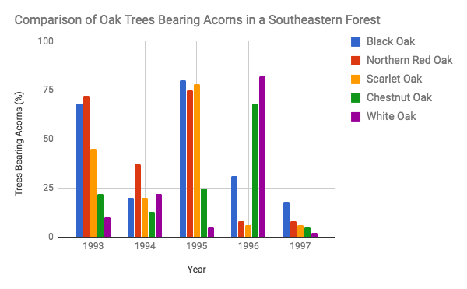
Consider Figure 1 above that shows 5 species of Quercus in a southeastern Appalachian forest producing acorns over a 5 year period.
- What patterns do you see in terms of species masting acorns in the same year?

Figure 2-1

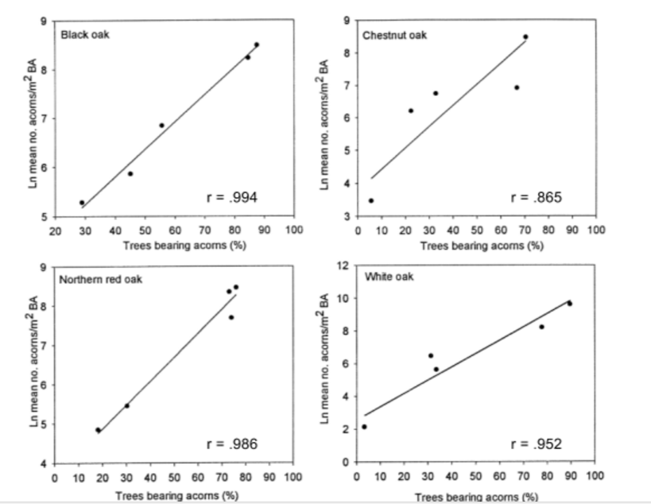
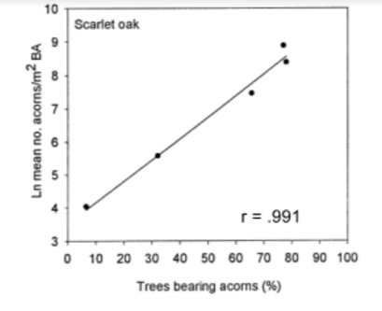
Figure 2 above shows a linear regression correlating the mean number of acorns produced each year (1993-1997) to the number of trees bearing acorns. The r value is called the “coefficient of correlation” and shows the degree of the relationship between the x and y axis. As r approaches 1, the relationship becomes stronger between the two axes. The slope of the line to the upper right indicates a positive correlation.

- Given the graphic data model above and the explanation in the caption, what prediction can you make about how strongly trees bearing acorns correlates to how many acorns will be produced in a given year? Use specific data as evidence to justify your prediction.

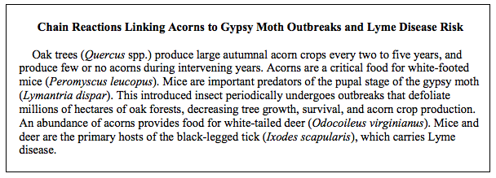
- Develop a food web model using the organisms above showing the energy relationships of this ecosystem. BE NEAT! Use PENCIL (or colored pencils) & RULER

- Above each arrow in the food web, place a “+” or “-” indicating a positive or negative outcome from the interaction.

- Design a controlled experiment that tests the relationship between acorn production and gypsy moth population. Include a null hypothesis, as well as an alternate hypothesis that the experiment tests. Write the procedure below.

- How confident would you be using the regression analysis in Figure 2 as a model to predict future lyme disease outbreaks in the southeastern US? EXPLAIN!

Scientist Richard Ostfeld of the Cary Institute of Ecosystem studies is quoted “The summer following a good mouse year, which is two summers following a good acorn year, we have found are the riskiest years for human exposure to Lyme.”

- Explain why there would be a lag time of two summers before humans are at peak risk for Lyme disease.

We have seen that trees may mast periodically in increase their survival. Ticks that carry Lyme disease are part of the food web that includes oak trees.

- Describe how a group of plant species trying to maximize survivorship indirectly impacts animal species by the spread of disease.

Figures 1 and 2 above from Greenberg, C.H and Parresol, B.R. 2000. Acorn production characteristics of Southern Appalachian oaks: a simple method to predict within-year crop size. Res. Pap. SRS-20 www.srs.fs.fed.us/pubs/rp/rp_srs020.pdf
2001 AP Environmental Science Exam Free Response. apcentral.collegeboard.com/apc/members/repository/sg_envir_sci_01.pdf
Lymes disease & acorns. Cary Institute of Ecosystem Studies. 2016. http://www.caryinstitute.org/discover-ecology/podcasts/lyme-disease-acorns

