Ecology Questions-Study Guide Name _______________________________ # _______
*You may have to RESEARCH some of these questions!
- List the 5 levels of ecological study and give examples of the focus of inquiry at each level:
- Give an example of a purposefully introduced species and an accidentally introduced species that have become pests in North America
- Mountains affect local climate. Describe their influence in the following three areas:
a. solar radiation:
b. temperature:
c. rainfall:
Indicate with a + or – whether the following are relatively high or low in oxygen level, nutrient content and productivity.
Biome | Oxygen level | Nutrient content | Productivity
Oligotrophic lake
Eutrophic lake
Headwater of stream
Turbid river
Estuary

- Define ecology:

- What are biomes? Give 6 examples and defining characteristics

- What accounts for the similarities in life forms found in the same type of biome in geographically separated areas?

- Identify the types of survivorship curves shown below and give examples of groups that exhibit each curve.
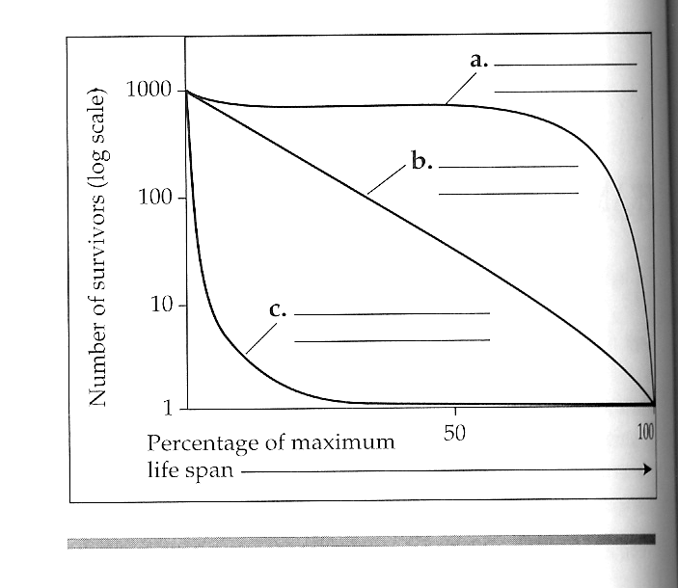

- Mortality, number of offspring per reproduction, and prenatal investment are usually interrelated. On the following graphs, sketch the relationship you would predict between the variables.

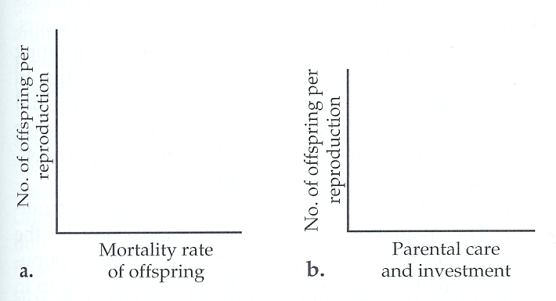

- Label the exponential (a) and logistic (b) growth curves, and show the equation associated with each curve. What is K for the population show with curve b?
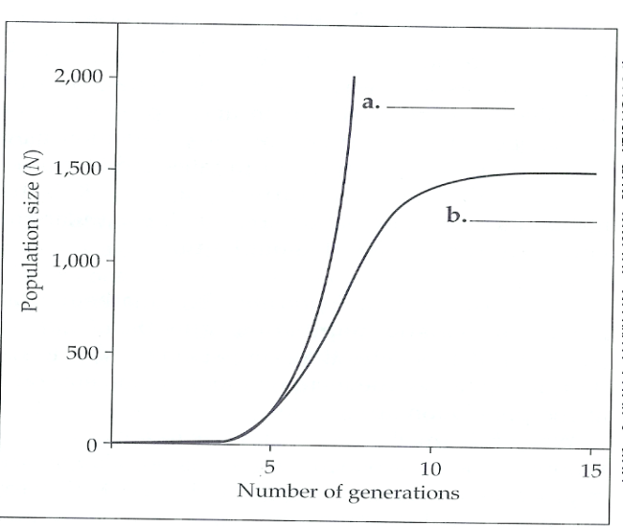

- List some density-dependent factors that may limit population growth
- List some abiotic factors that may cause population fluctuations.
- Species composition and distribution in most plant communities appear to be individualistic. What may explain the occasional occurrence of sharp delineations in species composition between communities?
- Name the following 2 types of mimicry:
  - Harmless species resembling a poisonous or distasteful species:
  - Mutual imitation by two or more distasteful species:
- Name and give examples of the interspecific interactions symbolized in the table:

 | Interactions | Examples
+/+
+/0
+/-
-/-
- Explain the importance of keystone species.
- Many freshwater lake communities appear to be organized along the top-down model. What actions might ecologists take if they wanted to use biomanipulation to control excessive algae blooms in a lake with four trophic levels (algae, zooplankton, primary predator fish, and top predator fish)?
- Compare & contrast primary vs. secondary succession.
- List some ecosystems with high rates of production.
- List some ecosystems with low rates of production.
- The open ocean has low net primary production yet contributes the greatest percentage of earth’s net primary production. Explain.
- Antarctic seas are often more productive than most tropical seas, even though they are colder and receive lower light intensity. Explain.
- Why is production efficiency higher for fishes than for birds and mammals?
- Assuming a 10% trophic efficiency (transfer of energy to the next tropic level), approximately what proportion of the chemical energy produced in photosynthesis makes it to a tertiary consumer?
- In which natural ecosystem do nutrients cycle the fastest? Why?
- In which natural ecosystem to nutrients cycle the slowest? Why?
- What is the effect of loss of vegetation on nutrient cycling?
- List some of the potential consequences of global warming:
- Explain biomagnification and the consequences to organisms in highest trophic level.
- Two processes that emerge at the ecosystem level of organization are energy flow and chemical cycling. Develop a concept map that explains, compares, and contrasts these 2 processes.

- Describe four or five human intrusions in ecosystem dynamics that have detrimental effects.
- Give an example of how each of the following causes of the biodiversity crisis has reduced population numbers or caused extinctions.
a. habitat destruction:
b. introduced (non- native) species:
c. overexploitation
d. disruption of food chains:

- What are the major threats to biodiversity, listed in order of importance?
- How does the loss of biodiversity threaten human welfare?
- Explain why an endangered species is always on the verge of extinction.
- Go over: Population Problems
- Go over: Simpson Diversity Index

