NAME ________________________________________________ DATE _____________ # ________

ECOLOGY STUDY GUIDE- Part 1: ECOLOGICAL INTERACTIONS STUDY GUIDE

DIRECTIONS – Use your awesome brain and your notes to answer these questions. This will help you prepare for your TEST.

1. What are the five levels of ecological organization? List them and then describe them using your own words.
LEVEL | DESCRIPTION

2. Give an example of how you could study a population in nature. Explain why this is a population level study.

3. Give an example of how you could study a community in nature. Explain why this is a community level study.

4. Give an example of how you could study an ecosystem in nature. Explain why this is an ecosystem level study.

5. What is the largest level of ecological organization? What is the smallest?

6. If a scientist is studying how chemicals that are sprayed on a nearby farm affect the survival rate of frog eggs in a small pond, what level of ecological organization are they studying? Why?

7. What is a population? How is it different from a community?

8. What is population density? Give an example.

9. How does population density change over time if a population is experiencing exponential growth?

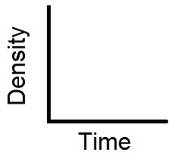

10. Draw what exponential growth looks like on the axes to the right

11. When a population is experiencing exponential growth, how does the
birth rate compare to the death rate?

12. How does population density change over time if a population is
experiencing logistic growth?

13. Draw what logistic growth looks like on the axes to the right
Also, label the carrying capacity.

14. What is carrying capacity? What causes a population to reach its carrying capacity?

15. When a population has reached its carrying capacity, how does the birth rate compare to the death rate?

16. How does population density change over time if a population is experiencing a boom/bust cycle?

17. Draw what a boom/bust cycle looks like on the axes to the right

18. What might cause a population to “boom”? What might cause it to “bust”?

19. What is a limiting factor? How do they affect population growth?

20. What is the difference between density-dependent and density-independent limiting factors?

21. Complete the table below. Classify each factor as density-dependent or density-independent. Then, explain your choices.
FACTOR | DENSITY-DEPENDENT or DENSITY-INDEPENDENT | EXPLAIN YOUR CHOICE
Male elephants fight over female elephants

A massive flood wipes out half of a population of trees along a river

A fungus spreads throughout a large ant population more easily than a small population

22. What might cause two different species in a community to compete with each other?

23. What is a niche?

24. What is competitive exclusion? What causes it?

25. What is predation? What are some adaptations that prey have to help them with this interaction? What are some adaptations that predators have?

26. Complete the table below. Decide if an interaction is (+/+), (+/-), or (+/meh), then give an example
INTERACTION | (+/+), (+/-), or (+/meh) | EXAMPLE
COMMENSALISM

MUTUALISM

PARASITISM

27. What is biodiversity?

28. What is a trophic level?

29. Describe the biodiversity and species abundance of a healthy community.

30. Describe the biodiversity and species abundance of an unhealthy community.

AHHHH! THERE ARE MORE QUESTIONS ON THE BACK!

USE THE DIAGRAMS BELOW TO ANSWER THE NEXT 3 QUESTIONS

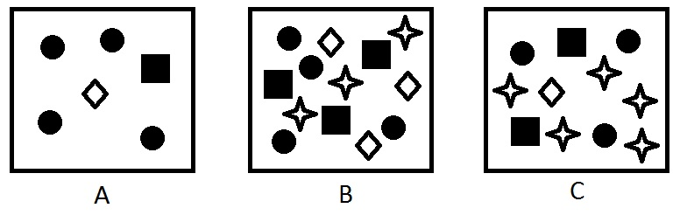

31. Fill in the table below to identify the biodiversity of each community:

COMMUNITY | BIODIVERSITY
A

B

C

32. Fill in the table below to compare the species abundance of each community:

COMPARISON | WHICH IS MORE HEALTHY? | HOW DO YOU KNOW?
A vs. B
A vs. C
B vs. C

33. Overall, which of the three communities is the least healthy? Which is the most healthy? How do you know?

