Name ____________________________________ # _______

ENZYME BASICS PRACTICE

‘Lock and key’ model: (*Keep in mind the ‘induced fit’ model is more acceptable, but can’t show without an animation)
1. Label the diagram using the words: active site, products, enzyme, substrate
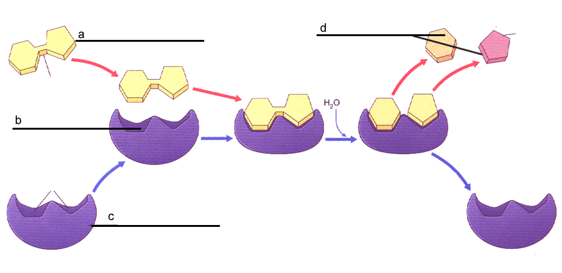
e._____________________
ENZYME FUNCTIONS:
2. Match the following words with their definitions:
Product Active site Enzymes Catalyst
Substrate Activation Energy
- Amount of energy required for a chemical reaction to occur
- Substances that bring about a chemical reaction without being changed itself
- Substance that an enzyme changes into a product
- Regions on surfaces of enzymes that fit the substrate
- Substance formed from the substrate at the end of a chemical reaction with a an enzyme
- Proteins that speed up chemical reactions
ENZYME PROPERTIES:
Answer true of false to the following statements:
a Enzymes interact with specific substrates
b Enzymes speed up reactions.
d. One enzyme can be used for many different types of chemical reactions.
e. Enzymes are re-used (recyclable) after a reaction.

ENZYME NAMES:
3. Enzyme names usually end with ____
4. Enzyme are usually named after the ________ with which they react. Example: ___________
ENERGY OF ACTIVATION:
5. What is the energy of activation?
6. Refer to the graph of the reaction pathway without an enzyme to the right. Draw a line/curve on the graph that shows the reaction pathway if an enzyme is added to the reactants.
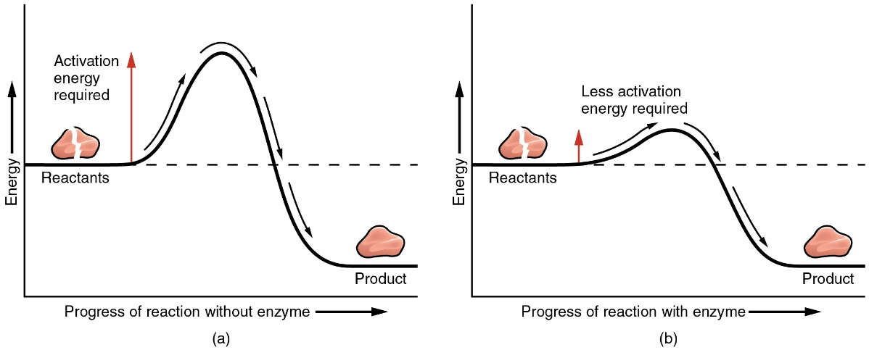
FACTORS THAT AFFECT THE ENZYME RATE OF REACTION
7. Circle the correct answers.
a. Raising the temperature slightly will [ increase | decrease | not change ] the rate of reaction
b. Keeping the pH around the optimal pH will [ increase | decrease | not change ] the rate of reaction.
d. Increasing the salinity of solution will [ increase | decrease | not change ] the rate of reaction.
8. Place a check mark next to the things that are expected to INCREASE the rate of an enzymatic reaction
a. _______ Add more enzyme
b. _______ Add more substrate
c. _______ Adjust pH to optimal level
d_______ Add a non-competitive inhibitor
e._______ Freezing

8. The enzyme pancreatic amylase is manufactured and secreted by the pancreas into the small intestine. Pancreatic amylase breaks down starch into a smaller sugar. Pepsin is an enzyme that is released by the stomach and functions to break down proteins into amino acids.
The following graph shows the pH at which both pepsin and pancreatic amylase can function in the body. If the pH of the body falls above or below the graphs for each enzyme respectively, that enzyme will denature and no longer function. The higher the curve of the graph, the more productive the enzyme.
Which of the following statements is true with respect to Figure 1?
  - T or F: Pepsin and pancreatic amylase could never function together in the same part of the body at the same time.
  - T or F: Pancreatic amylase could function in the stomach with a pH of 1-2.
  - T or F: The optimal pH for the functioning of pepsin is approximately 8.5 to 9.
  - T or F: Pancreatic amylase is used in the small intestine. Normally, the small intestine must be slightly acidic in order for it to function.

