Esters Questions Name ___________________________ # ______
1.
Which of the molecules below would be considered to be an ester?
a.

b.

c.

d.

2. The IUPAC name for the molecule below would be: 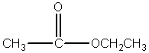
 | a. | methyl propanoate

 | b. | ethyl ethanoate

 | c. | ethyl propanoate

 | d. | ethanol ethanoic acid

3. Identify the ester linkage in acetylsalicylic acid (aspirin) shown below. 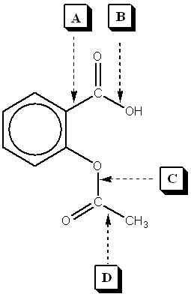

 | a. | A

 | b. | B

 | c. | C

 | d. | D

4. Which of the following is a product of the saponification reaction shown below? 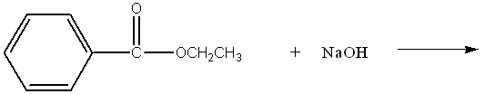
 | a. | phenol

 | b. | sodium benzoate

 | c. | benzoic acid

 | d. | sodium acetate
FYI- Back to Biology: The below molecule is produced in the first step of Glycolysis in Cellular Respiration (oxidation of glucose), as ATP ADP to start the process, and the phosphate bonds to glucose (see p. 750)
5. Phosphate esters are important biological molecules. Shown below is the structure of glucose 6-phosphate. Which of the statements below is true? 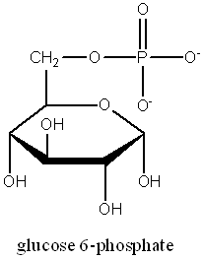
 | a. | This is a monoester of phosphoric acid.

 | b. | This is a diester of phosphoric acid.

 | c. | This is a triester of phosphoric acid.

 | d. | This is a tetraester of phosphoric acid.

6. Predict the product from the reaction shown below.
a.

b.

c.

d.

7. The carbonyl group in the carbohydrate fructose is that of a(n): 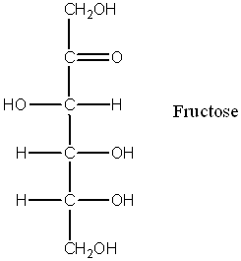
 | a. | aldehyde

 | b. | carboxylic acid

 | c. | ketone

 | d. | ester

8. Phosphate esters are important biological molecules. Shown below is the structure of glucose 6-phosphate. Identify the ester linkage. 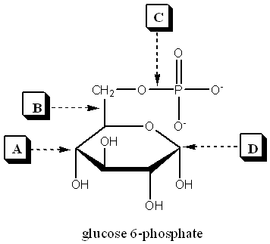
 | a. | A

 | b. | B

 | c. | C

 | d. | D

9. Choose the molecule that would have the highest boiling point.
 | a. | butanal

 | b. | 1-butanol

 | c. | butane

 | d. | 2-butanone

10. The IUPAC name for the molecule below would be: 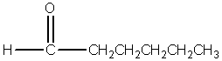
 | a. | 1-hexanone

 | b. | hexanal

 | c. | heptanal

 | d. | pentanal

11. Esters can be produced by the acid catalyzed reaction of:
 | a. | an aldehyde and an alcohol

 | b. | a carboxylic acid and an alcohol

 | c. | two alcohols

 | d. | a carboxylic acid and an amine

12. A reaction in which water is removed from a compound is known as:
 | a. | addition

 | b. | hydrolysis

 | c. | dehydration

 | d. | hydrogenation

13. Saponification is:
 | a. | the formation of an ester

 | b. | the basic cleavage of an ester linkage

 | c. | the removal of water from a molecule

 | d. | the reaction of sugars to produce ethanol and carbon dioxide

14. A wax is an ester of a long chain acid and a long chain alcohol. Choose the molecule below that would be considered a wax.
a.

b.

c.

d.

15. What is the name of the molecule shown in #1? _________________________________
16. What is the name of the answer you chose from #6? ______________________________
17. Use your book (Ch 19 p. 503) to help with the following question: The reaction of 2 carboxylic acids produces an anhydride via dehydration synthesis. Show the reaction of 2 propanoic acids below and name the product.

18. To prepare for tomorrow’s lab, read p. 502 and answer the following:
A. What compound in willow bark relieved pain?

B. The hydrolysis of this compound yielded:

C. What were the side effects of the above compound?

D. Explain (give reactants and product) what chemists of the Bayer Corp. did to the compound to make aspirin.

