Exploring Trophic Cascades Name ________________________________ # _______
Exploring Trophic Cascades HHMI website

Introduction:
Which trophic level limits the population size, biomass and energy in the other trophic levels? Justify your answer.

- Use arrows to make a model of the trophic relationships (food chain) between sea otters, sea urchins and kelp. (Note: this is a very simplified version of the food chain in this ecosystem).
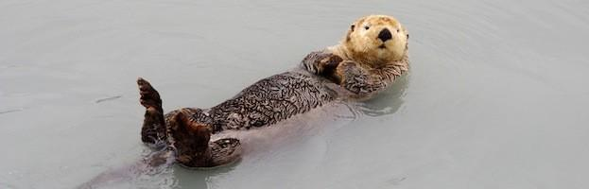

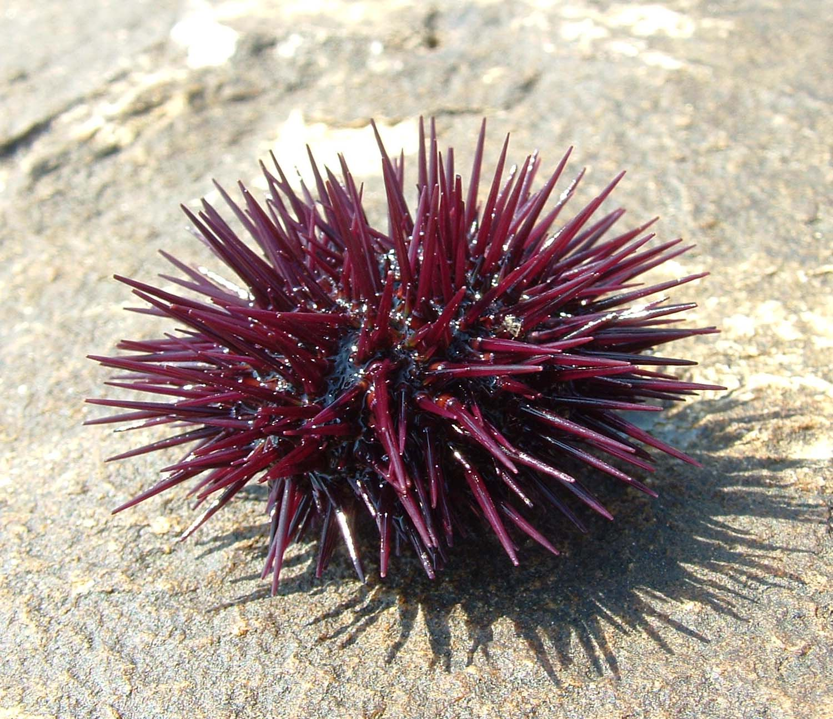

- Watch the video as a class and then begin to navigate through the click and learn activity.

- Once you are done with all 3 Introduction Slides, click on the X in the upper right hand corner.
- After going through the first few slides, revise your model above to include:
- Solid arrows ( → ) to indicate direct effects
- Dashed arrows ( ---> ) to indicate indirect effects (use a different colored pen)
- Plus (+) or minus (-) symbols to indicate nature of the effect

- The consequence of hunting sea otters to near extinction illustrates what type of effect on an ecosystem, direct or indirect? Explain.

- This probably doesn’t agree with your original statement regarding which trophic level limits the population of the other trophic levels. Explain how both statements can be true.

- In order to track the changes in an ecosystem, let’s look at how members of the community affect each other in this simple system. Continue through the slides. Identify and explain how the loss of the kelp forests affects either seagulls or bald eagles.

- What is a trophic cascade?

Case Studies: Make a model of each trophic cascade using the lines and arrows as you did in the sea otter model. Be sure to add notes about the +/- effects. Answer the question associated with each ecosystem.
- Arctic Tundra: Foxes have a (Positive or Negative ; Direct or Indirect) effect on the grass population.

Model:

- Midwestern Lake: How do changes in the bass effect carbon dioxide levels?

Model:

- African Savannah: What is the relationship between rinderpest virus and percentage of vegetation burned?

Model:

- Venezuelan Jungle: Do large predators have a positive or negative effect on herbivores?

Model:

- Give an example from one of the case studies of a population limiting factor. Is it density dependent or independent factor. Justify.

