**Fats**  Name __________________________ # ______

**Read the following articles and answer the questions at the end of the document:**

First, a very brief review of the language and names of compound classes would probably be helpful. As noted above, the term “lipid” is a very general term to designate organic compounds that include fats, oils, waxes and steroids, and assorted other compounds. What they have in common is that they are all hydrophobic, as noted above. This is not a very satisfying or specific definition. Among chemists a better definition would be“Lipids are fatty acids and their derivatives, and substances related biosynthetically or functionally to these compounds.” Triglycerides, then, are esters made up of a glycerol—an organic alcohol—backbone and three fatty acids.

In most common uses, the term “triglyceride” and the term “fat” are synonymous. Fats can be either unsaturated or saturated, as noted above, and saturated fats may be monounsaturated (one double bond in the molecule) or polyunsaturated (more than one double bond). Saturated fats have different health implications from unsaturated fats. And if the fat is unsaturated the molecule may exist in more than one isomeric form, called either *cis* or *trans.* In the *cis* isomer the atoms attached to the doubled bonded carbons are arranged on the same side of the double bond and in the *trans* isomer those atoms are on opposite sides of the double bond. This shift also changes the properties of the molecules. Your students will have seen a reference to this issue because of the negative publicity about “*trans*-fats.”

**Saturated Fats** – Recall from earlier in this section of the Teacher’s Guide that fats (triglycerides) are made up of three fatty acid molecules and a glycerol molecule that acts as a backbone for the larger molecule. Because the fatty acid components of fat molecules tend to be longer –C-C– chains, the properties of these fatty acids determine the overall properties of the molecule. As we think about fats and diet and health, we need to remember that fatty acids (and, therefore, fats) may be either saturated or unsaturated. Also recall that these molecules are generally linear in shape and so “stack” together so that there are relatively strong London dispersion forces between them. The existence of these attractive forces means that the melting points of saturated fats are high relative to other fats, and this, in turn, means that saturated fats tend to be solids at room temperature. So we find saturated fats in foods like the ones listed on the American Heart Association web site:

Saturated fats occur naturally in many foods. The majority come mainly from animal sources, including meat and dairy products. Examples are:

* 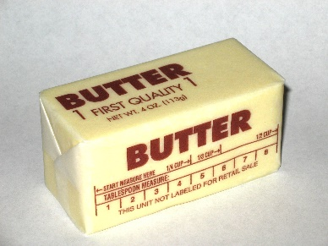fatty beef,
* lamb,
* pork,
* poultry with skin,
* beef fat (tallow),
* lard and cream,
* butter,
* cheese and
* other dairy products made from whole or reduced-fat (2 percent) milk.

(<https://www.heart.org/HEARTORG/GettingHealthy/NutritionCenter/HealthyEating/Saturated-Fats_UCM_301110_Article.jsp>)

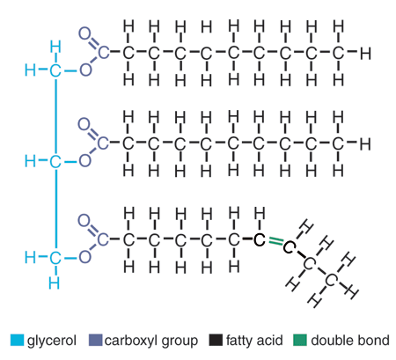 **Unsaturated fats** – Fats that contain one or more double covalent bonds are labeled “unsaturated” because additional hydrogen atoms could be added to some of the carbon atoms. There may be one double bond (monounsaturated) or multiple double bonds (polyunsaturated) in the molecule. The existence of double bonds has an effect on the molecular geometry. Molecules   
of unsaturated fats have slight bends or “kinks” in them, making it difficult for neighboring molecules to pack tightly together as saturated molecules can.

The molecule diagrammed at right shows the bending of the fat molecule at the double bond. As a result the London dispersion forces between unsaturated molecules are weaker, resulting in lower melting points. So, unsaturated fats tend to be liquids at room temperature. Sources of unsaturated fats include canola oil, peanut oil, olive oil, avocados, almonds, hazelnuts, pecans, pumpkin seeds, sesame seeds, sunflower oil, corn oil, soybean oil, flax seeds, walnuts, and fish.

**Trans fat** – This type of fat is man-made (although some animals produce small amounts) and the least healthy type. It can lead to serious health problems The major issue is that *trans* fat tends to raise "bad" LDL- cholesterol and lower "good" HDL- cholesterol, although not as much as saturated fat.

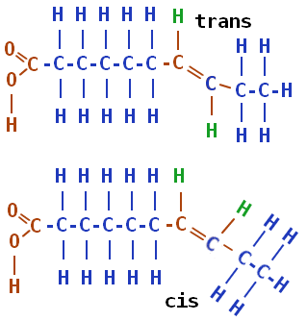 To the right is a diagram of *cis* and *trans* isomers for a fatty acid. The position of the hydrogen atoms (in green) that are attached to the double-bonded carbon atoms determine the isomer. In the lower structure both hydrogen atoms are on the same “side” of the double bond, making it the *cis* isomer. The upper diagram shows those hydrogen atoms on opposite sides of the double bond in the *trans* configuration. Biologically the two isomers have different properties.

([*http://chemistry.tutorvista.com/organic-chemistry/alkene-nomenclature.html*](http://chemistry.tutorvista.com/organic-chemistry/alkene-nomenclature.html))

A December 2007 *ChemMatters* article describes the problems with *trans* fat and the form of isomerism involved in the conversion of unsaturated fats to partially hydrogenated fats that produces *trans* fat.

In naturally occurring unsaturated fats, the double bonds are *cis* double bonds. *Cis* comes from Latin and means “on this side.” This means that both hydrogen atoms are on the same side of the double bond, and both ends of the long carbon chains are on the same side. The opposite of a *cis* double bond is one that is *trans*—also Latin, meaning “across.” In a *trans* double bond the hydrogen atoms are on opposite sides of the double bond, and the chains are on opposite sides.

One very interesting feature about the *cis* double bonds found in unsaturated fats is that the chains with *cis* bonds are not three-dimensional long tubes like saturated fatty acids. The *cis* bonds create “kinks” in the chains, so the chains don’t stack up in a nice well-behaved, orderly fashion like saturated fats. With less attractive molecular surface in contact with neighboring molecules, these plant fats or oils are not solids, but rather are liquids at room temperature.

Think corn oil, peanut oil, or olive oil. The other feature of naturally occurring unsaturated fats is important from a food production and shelf-life standpoint. Fats with *cis* double bonds are more likely to react with the oxygen in the air (oxidation) than those with either *trans* double bonds or all single bonds (saturated fats).

This is linked to the fact that *cis* fats are less stable and more reactive than *trans* fats or saturated fats. Oxidation of fats breaks the long chains into shorter chains to yield stinky and unpleasant tasting products—in other words, *rancid*. No one wants to eat a rancid potato chip! Manufacturers are well aware of the problem.

On the one hand, companies understand the importance of positive health claims. On the other hand, if they use healthier natural unsaturated fats, they run the risk of having the product turn rancid before it finds its way into the vending machine or convenience store.

So what is a manufacturer to do? To the rescue: *partial* hydrogenation! . . . . During hydrogenation, a *cis* fat is heated at high pressure in the presence of hydrogen gas, H2 (g), and a metal catalyst, such as nickel. In the process, hydrogen is added across the double bond, one H atom to each carbon atom, and the carbon-carbon double bond becomes a single bond. If all the double bonds are hydrogenated, the unsaturated fat becomes saturated. However, if only some of the double bonds are hydrogenated, the fat is described as “partially hydrogenated”.

But another important thing happens to the double bonds in the partial hydrogenation process: The double bonds that are NOT hydrogenated are converted from *cis* to *trans*. Overall, the fat is still unsaturated, but now the double bonds are *trans* rather than *cis*.

(Kimbrough, D. The Solid Facts about Trans Fats. *ChemMatters* **2007**, *25* (4), pp 15–16)

Historically, hydrogenation chemistry was developed in the late 1890s by French chemist and Nobel laureate Paul Sabatier. The German chemist Wilhelm Normann showed in 1901 that liquid oils could be hydrogenated, and he patented the process in 1902. In 1909, Procter & Gamble acquired the U.S. rights to the Normann patent, and in 1911 they began marketing the first hydrogenated shortening, Crisco (composed largely of partially hydrogenated cottonseed oil). Production of hydrogenated fats increased steadily until the 1960s, as processed vegetable fats replaced animal fats in the U.S. There were suggestions in the scientific literature as early as 1988 that *trans* fats could be a cause of the large increase in coronary artery disease. In 1994, it was estimated that *trans* fats caused 30,000 deaths annually in the U.S. from heart disease.

On January 1, 2006, the U.S. Food and Drug Administration required labels to include the amount of *trans* fat in foods. Even though there have been attempts to limit the use of *trans* fats in food products, it can still be found in many processed foods including fried foods like doughnuts, baked goods, pie crusts, biscuits, frozen pizza, cookies, crackers, and stick margarines. Even though the nutrition label may not say “*trans* fat” look for terms like “partially hydrogenated oils” on the label.

**Cholesterol** – Cholesterol is considered a lipid. It is found in all animal cells as part of the cell membrane. The brain actually contains more cholesterol than any other organ. Structurally it has four hydrocarbon rings, three of which are 6-carbon rings and one of which is a 5-carbon ring. As you can see from the diagram at left, there is also a hydrocarbon chain attached to the 5-carbon ring and a hydroxyl group attached to one of the 6-carbon rings. Most of the molecule is nonpolar and, therefore, cholesterol is considered only very slightly soluble in water. The hydroxyl radical, although only a small part of the cholesterol molecule, is polar and allows cholesterol to react with phospholipids and become water soluble, as described below.

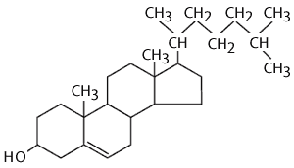

([*http://sphweb.bumc.bu.edu/otlt/MPH-Modules/PH/PH709_BasicCellBiology/PH709_BasicCellBiology24.html*](http://sphweb.bumc.bu.edu/otlt/MPH-Modules/PH/PH709_BasicCellBiology/PH709_BasicCellBiology24.html))

Cholesterol can also react with fatty acids in esterification reactions.

**More on phospholipids, lipoproteins and cholesterol**

The Pickett article describes the relationship of fats and cholesterol, one of the key fat-related relationships in the national discussion of heart health. Physicians warn us that too much cholesterol in our blood is a warning sign for heart attack or stroke. But we know that in order for substances like cholesterol or fats to be in our blood, they must be water soluble. We already know that fats are insoluble in water, and the article tells us that cholesterol is only slightly soluble. How are these substances transported via the blood throughout the body?

There are two parts to this answer. Fat molecules are very large. In order to pass through the intestinal wall the molecules must be broken up*.* Fats are mixed with a biological detergent called bile, which is produced in the liver and stored in the gall bladder. The mixing (emulsifying) of the detergent with the fats allows for the non-polar end of the detergent to interact with the non-polar end of the fat (the fatty acid end) while the polar end of the detergent bonds with the polar end of the fat (the glyceride end) just as regular soaps and detergents would do when you wash greasy dishes with soap or detergent. Once the fat is emulsified in the digestive “juices”, it can be broken apart by hydrolysis to yield water soluble fatty acids, glycerols and mono- and di-glycerides which are then small enough and soluble enough to pass through the intestinal wall into the blood stream.

In intestinal cells, the parts are reassembled and the resulting fats are combined with phospholipids, simply modified triglycerides in which one of the fatty acid chains is replaced with a phosphate radical as shown in the diagram at right. The phosphate is polar, and as a result the phosphate “end” of the phospholipid molecule is polar and hydrophilic and the fatty acid “end” is nonpolar and hydrophobic. When they interact with fats and cholesterol they orient themselves so that the polar heads are facing the water molecules and the hydrophobic fatty acids are oriented toward the cholesterol. The phospholipid acts as a bio-emulsifier connecting blood (water) and cholesterol so that the cholesterol can be transported through the blood. This unit combines with specialized carrier molecules called apoproteins and the resulting globular structure is called a lipoprotein (see diagram at right, below). The hydrophilic phospholipid layer forms the outer shell and interacts with water via hydrogen bonding while the hydrophobic fat and cholesterol are in the interior of the globule and are attracted to the phospholipid via dispersion forces.

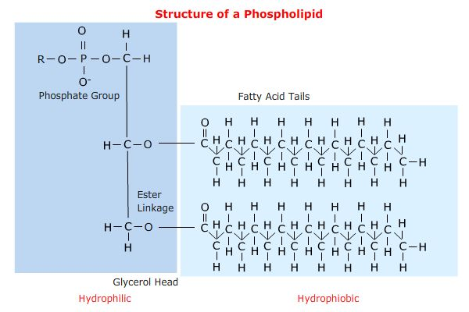

([*http://telstar.ote.cmu.edu/biology/MembranePage/index2.html*](http://telstar.ote.cmu.edu/biology/MembranePage/index2.html))

Some of these carrier units are more dense and some are less dense, due to differences in the percent of fat in the unit. We know the lower density units as LDL or low density lipoprotein, and we know the high density units as HDL or high density lipoprotein. Your students may recognize LDL as the so-called "bad cholesterol," which carries cholesterol away from the liver, to various organs. In contrast, HDL's tendency to remove excess cholesterol from arteries to return it to the liver has earned it the name "good cholesterol".

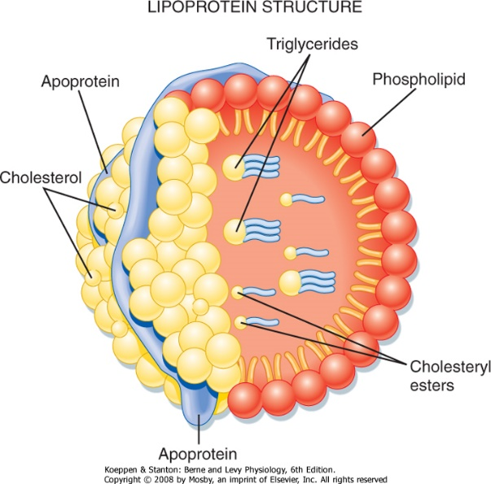

([*http://users.atw.hu/blp6/BLP6/HTML/C0389780323045827.htm*](http://users.atw.hu/blp6/BLP6/HTML/C0389780323045827.htm))

In addition to the well-known HDL and LDL lipoproteins, there are three other classes of smaller globular lipoprotein formations called intermediate density lipoproteins, very low density lipoproteins and chylomicrons. The table below shows the per cent makeup of each of the lipoprotein structures. Note that the LDL has twice the percent of fat (“triacylglycerol” on the table) as HDL. The lower density is the result of fat’s lower density.

For a young healthy research subject with weight about 154 pounds, the following applies:

|  |  |  |  |  |  |  |
| --- | --- | --- | --- | --- | --- | --- |
| **Density**  (g/m[L](http://en.wikipedia.org/wiki/Litre)) | **Class** | Diameter (nm) | % protein | % cholesterol | % phospholipid | % triacylglycerol & cholesterol ester |
| >1.063 | [HDL](http://en.wikipedia.org/wiki/High-density_lipoprotein) | 5–15 | 33 | 30 | 29 | 4 |
| 1.019–1.063 | [LDL](http://en.wikipedia.org/wiki/Low-density_lipoprotein) | 18–28 | 25 | 50 | 21 | 8 |
| 1.006–1.019 | [IDL](http://en.wikipedia.org/wiki/Intermediate-density_lipoprotein) | 25–50 | 18 | 29 | 22 | 31 |
| 0.95–1.006 | [VLDL](http://en.wikipedia.org/wiki/VLDL) | 30–80 | 10 | 22 | 18 | 50 |
| <0.95 | [Chylomicrons](http://en.wikipedia.org/wiki/Chylomicrons) | 100–1000 | <2 | 8 | 7 | 84 |

([*http://en.wikipedia.org/wiki/Lipoprotein*](http://en.wikipedia.org/wiki/Lipoprotein))

**More on fats, diet and health**

There is a long history of recommendations about the kind of diet that is appropriate for American citizens. In 1894, the U.S. Department of Agriculture (USDA) published the first dietary standards for the country (see a digital copy of the document at <http://www.ars.usda.gov/SP2UserFiles/Place/80400530/pdf/hist/oes_1894_farm_bul_23.pdf> ). The first recommendations for daily food consumption appeared in 1917, and there were five food groups listed: milk and meat, cereals, vegetables and fruits, fats and fat foods (note that these were recommended), and sugars and sugary foods. Twelve major food groups were part of a 1933 version of recommended weekly food needs: milk; potatoes and sweet potatoes; dry beans, peas, and nuts; tomatoes and citrus fruits; leafy green and yellow vegetables; other vegetables and fruits; eggs; lean meat, poultry, and fish; flours and cereals; butter; other fats; and sugars.

The National Academy of the Sciences issued the first Recommended Daily Allowances (RDA) tables in 1941, and in 1942 the USDA released its “Basic Seven” daily food requirements, including green and yellow vegetables; oranges, tomatoes, and grapefruit; potatoes and other vegetables and fruit; milk and milk products; meat, poultry, fish, eggs, and dried peas and beans; bread, flour, and cereals; and butter and fortified margarine. These seven food groups were consolidated into four groups in 1956—milk and milk products; meat, fish, poultry, eggs, dry beans, and nuts; fruits and vegetables; and grain products.

Until the 1940s, heart disease and cancer were relatively minor diseases in the United States. In that time the major cause of death was infectious disease, and a high-calorie diet was considered helpful in recovering from illness. By the 1950s, however, heart disease had become a major health risk, accentuated perhaps by the heart attack suffered by President Eisenhower in 1955. According to a 1998 *Journal of Nutrition* article:

Real interest in dietary fat and its effects—particularly with regard to its role in cardiovascular disease—was stimulated by several papers published in the early 1950s. Gofman and his colleagues at the University of California, Berkeley published a paper in Science ([Gofman et al. 1950](http://jn.nutrition.org/content/128/2/449S.long#ref-6)) that detailed findings related to their new technique of separating plasma lipoproteins by ultracentrifugation. They showed that levels of certain of these lipoprotein classes were related to atherosclerotic heart disease and implicated dietary fat as a factor in this relationship. At about the same time Ancel Keys embarked on his worldwide epidemiologic investigations of dietary fat and heart disease prevalence, which showed that the level of dietary fat was related to mortality from heart disease ([Keys 1953](http://jn.nutrition.org/content/128/2/449S.long#ref-13)). In his “Seven Countries” study, [Keys (1970)](http://jn.nutrition.org/content/128/2/449S.long#ref-14) found a significant association between fat and saturated fat intake and heart disease mortality. [Yerushalmey and Hilleboe (1957)](http://jn.nutrition.org/content/128/2/449S.long#ref-34) pointed out that if 21 other countries were included, the association observed by Keys was weak and that a similar association could be advanced between animal protein intake and heart disease.

The role of dietary cholesterol in the etiology of heart disease had been a subject of much earlier research and speculation. The early history is detailed in a book published in 1958 ([Kritchevsky 1958](http://jn.nutrition.org/content/128/2/449S.long" \l "ref-17)). The observation that cholesterol was a constituent of the atherosclerotic plaque was noted in a pathology text published 150 years ago ([Vogel 1847](http://jn.nutrition.org/content/128/2/449S.long#ref-33)). Any number of investigators showed that atherosclerotic aortas contained significantly more cholesterol than normal ones. Others showed that cholesterol feeding alone was sufficient to establish cholesterol-rich lesions in the arteries of rabbits and chickens. Atherosclerotic lesions could be established in rats, dogs and monkeys by cholesterol feeding plus other dietary and hormonal manipulations. Although these findings led to innumerable experimental studies of cholesterol/fat feeding and atherosclerosis, [Stehbens (1989)](http://jn.nutrition.org/content/128/2/449S.long#ref-29) has argued persistently that the human and experimental lesions in animals are different enough to cast doubt on the validity of the experimental lesion as an example of human disease. Although the role of cholesterolemia and hyperlipidemia in the etiology of human atherosclerosis was not accepted unanimously in the 1950s, it was considered sufficient by some authorities to establish a case against high intakes of dietary fat and cholesterol. This was enough to open the door to dietary guidelines offered to the public for possible prevention or amelioration of heart disease.

(<http://jn.nutrition.org/content/128/2/449S.long>) (accessed online February 27, 2015)

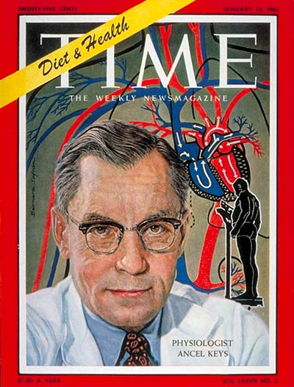The *ChemMatters* Pickett fats article references “the original study” that was done by Dr. Ancel Keys, pictured below, and published in 1970. It is commonly called the Seven Countries Study and it is the basis for the U.S. Dietary Guidelines advice to avoid fatty foods. Keys interest in the relationship between diet and cardiovascular disease began just after World War II. He observed that as food supplies became short in northern Europe after the war, deaths due to coronary artery disease also dropped. Keys conducted a series of small studies during which he theorized that it was high levels of cholesterol in the blood that predicted coronary artery disease and that high levels of dietary fat consumption was the main reason for elevated cholesterol levels.

To test this theory, Keys and colleagues initiated in 1957 a study of 12,000 men in Italy, the Greek Islands, Yugo­slavia, the Netherlands, Finland, Japan, and the United States—the seven countries. Subjects reported their food intake and Keys analyzed chemically the composition of the food reported by the subjects. He found that diets that included higher levels of saturated fats corresponded to both high blood cholesterol levels and death rates from heart attacks. On the other hand, diets that included fresh fruit and vegetables and large quantities of olive oil (what has become known as the Mediterranean diet) led to lower serum cholesterol levels and lower coronary death rates. The saturated fat–high serum cholesterol–coronary heart disease connection became known as the “lipid hypothesis”, and when Keys published the study in 1970, he also managed to convince federal officials to include statements in the U.S. dietary guidelines warning people to limit their consumption of fats, especially saturated fats. This was the beginning of the anti-fat campaign in the United States.

([*http://www.uh.edu/engines/AncelKeys.jpg*](http://www.uh.edu/engines/AncelKeys.jpg))

By the early 2000s researchers had discredited much of Keys’ study, citing, among other things:

* The fact that Keys did not choose countries/subjects randomly—he excluded countries where people consume a lot of fat and are not subject to high rates of coronary disease like France, Sweden, Switzerland and West Germany
* Results from Crete were featured in the report as exemplary. However, Keys took data from Crete during a severe post-World War II food shortage and during Lent when many had given up meat and cheese
* Keys excluded results from many participants without revealing this

By the time these shortcomings were revealed, however, Keys’ ideas were well entrenched in U.S. dietary guidelines and accepted as fact.

Even in the 2005 report *Nutrition and Your Health: Dietary Guidelines for Americans* from theU.S. Department of Agriculture (USDA), fats were still to be avoided. The 2005 version of the guidelines recommended:

* Total fat intake of 20 to 35 percent of calories is recommended for adults and 25 to 35 percent for children age 4 to 18 years. At high intakes of fat (> 35 percent of energy), the risk increases for obesity and coronary heart disease (CHD). This is because fat intakes that exceed 35 percent of energy are associated with both increased calorie and saturated fat intakes.
* The relationship between saturated fat intake and LDL cholesterol is direct and progressive, increasing the risk of cardiovascular disease (CVD). Thus, saturated fat consumption by adults should be as low as possible while consuming a diet that provides 20 to 35 percent calories from fat.
* The relationship between trans fatty acid intake and LDL cholesterol is direct and progressive, increasing the risk of CHD. Trans fatty acid consumption by all population groups should be kept as low as possible, which is about 1 percent of energy intake or less.
* The relationship between cholesterol intake and LDL cholesterol concentrations is direct and progressive, increasing the risk of CHD. Thus, cholesterol intake should be kept as low as possible, within a nutritionally adequate diet.

In 2013 and 2014, new study results were reported indicating no difference in cardiovascular disease between people who ate saturated fats and those eating unsaturated fats. Nutritional science is beginning to question “the lipid hypothesis.” The headlines in popular newspaper and magazines that announced these results claimed that there was no link at all between saturates fat and heart disease, but these kinds of claims are not fully documented and are being debated in science circles. There seems to be little agreement on the current status of fats in our diet.

As the Pickett article suggests, many people have replaced fats with carbohydrates in their diet. The article notes that, “Despite the overall reduction of fat in our diets, obesity and type 2 diabetes have risen. From 1980 to 2000, the incidence of type 2 diabetes in the United States increased by 166%; between 1980 and 2000, obesity rates doubled among adults; and cardiovascular disease remains the leading cause of death in the United States. Fat consumption has been reduced since the 1970s, so what is causing these health problems now?” Some scientists believe that many people have replaced fats with carbohydrates which break down into glucose. As a result, the body produces insulin, a good storer of fat. Additionally, some carbohydrates like fructose cause the liver to produce triglycerides in the blood, and that may lead to heart disease.

So it seems we are in a period of changing attitudes about the role of fats in our diet. More and more is now known about the chemical changes that fats undergo in the body and the chemicals that result. The 2015 Dietary Guidelines will be released later in the year and will likely recommend that no more than 10% of our calories come from saturated fats. It will recommend diets that are rich in vegetables, fruit, whole grains, seafood, legumes, and nuts; moderate in low- and non-fat dairy products, lower in red and processed meat; and low in sugar-sweetened foods and beverages and refined grains.

You can urge students to monitor the debate about dietary nutrients in both the popular press and in the more scientific literature. Use the “Additional Web Sites” below as a starting points for student research.

**More on milk fat**

The article begins its examination of fats with two paragraphs about the fat in milk. It is an apt example of the trend to avoid food items containing fat. Americans drink 37% less milk today than they did in 1970. Per capita consumption of whole milk has decreased by 78% since 1970.

What is the fat content of milk? Milk contains approximately 3.4% total fat. Of this, 65% is saturated, 30% is monounsaturated and 5% is polyunsaturated. The fat in milk is a complex mixture of about twenty individual fats. Some of the fats are present in very small amounts but contribute to the taste of milk or milk product. Below is a more detailed breakdown (by mass) of the fat content of whole milk. Note that the substances listed are actually fatty acids. Many references simply list fatty acids and ignore the glycerol component.

**Saturated fats** –

palmitic acid: 31%

myristic acid: 12%

stearic acid: 11%

lighter saturated fats: 11%

pentadecanoic acid and heptadecanoic acid: traces.

**Unsaturated fats** –

oleic acid: 24%

palmitoleic acid: 4%

linoleic acid: 3%

alpha-linolenic acid: 1%.

To summarize:

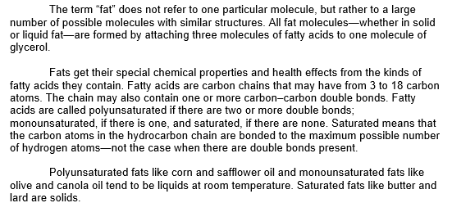

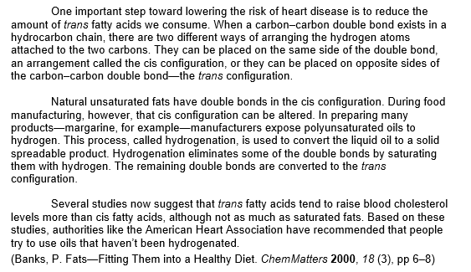

**SEE NEXT PAGE FOR QUESTIONS:**

Name __________________________________ Block _______ # ______

*\*There will be several test questions over this material. Keep the articles for study and only turn in this sheet of paper (you may detach it if it’s attached).*

**QUESTIONS**

* 1. What kind of fat was associated with a greater risk of heart disease in the 1970 study of more than 12,000 men from seven countries?
  2. What is the chemical term for fat, according to the article?
  3. Name the two component parts of triglycerides.
  4. What is the chemical notation for a carboxyl group?
  5. What is the energy density of fat?
  6. Identify the intermolecular forces that hold saturated fat molecules close together.
  7. How do intermolecular forces in saturated fats vary with molecular size?
  8. What is unique about the chemical bonding in unsaturated fats?
  9. Compare the strength of intermolecular forces in unsaturated fats with those in saturated fats.
  10. The article says that saturated fats raise cholesterol levels. Which kind of cholesterol, LDL or HDL, is raised?
  11. According to the article, despite the decline in fats intake in our diet, two health issues have increased. Name them.
  12. The article connects decreased dietary fat consumption since the 1970s with an increase in type 2 diabetes in the U.S. Give one possible explanation for this that is offered by the article.