Name __________________________ # _____

The Carbon Cycle and Global Warming

- Global Warming and Greenhouse Gases

This graph shows changes in global temperature and CO₂ concentration in the earth’s atmosphere. Global temperature varies from year-to-year, due to multiple factors such as volcanic eruptions and El Niño ocean currents. We will focus on the overall temperature trend.

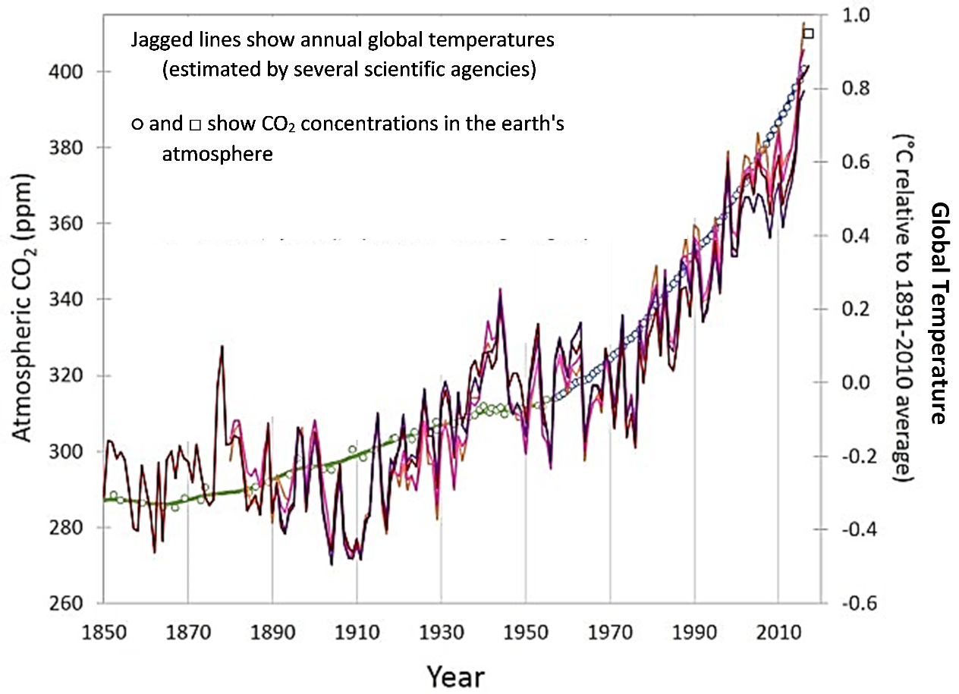
1a. The overall trends in this graph show _________________ in global temperature and
(a decrease/an increase)
__________________ in CO₂ concentration.
(a decrease/an increase)

1b. The global warming trend
- was most rapid from 1850 to 1920.
- has occurred steadily in every decade since 1850.
- has been more rapid in recent decades.

2. Last winter, two weeks were unusually cold. Your friend complained that she was freezing and said that this was proof that there really isn’t any global warming. Do you agree or disagree? Explain why.

3. Since 1900, there have been increases in:
- global temperature
- CO₂ concentration in the earth’s atmosphere
- men’s average height.
Do these correlated trends mean that the increase in men’s height caused the increase in global temperature? yes ___ no ___ Explain why or why not.

4. Scientists need additional types of evidence to test the hypothesis that increased CO₂ in the earth’s atmosphere has caused the increase in global temperature. To test this hypothesis, scientists have:
- investigated whether there is a mechanism that can explain how CO₂ in the atmosphere could cause global warming
- tested the ability of their hypothesis to predict future trends
- evaluated whether other hypotheses could account for the observed trends.
As you read the evidence on this page and the next page, use the appropriate letter to label each type of evidence.

Sunlight warms the earth, and the earth radiates heat energy back out to space. Laboratory experiments have shown that CO₂ molecules absorb heat energy and then radiate heat energy in all directions. CO₂ molecules in the air absorb some of the heat energy radiated by the earth and then radiate some of the heat energy back to earth. When there is more CO₂ in the atmosphere, more heat energy is radiated back to earth and the earth warms up. This warming effect explains why CO₂ is called a greenhouse gas. Other greenhouse gases include methane (CH₄) and nitrous oxide (N₂O).

5. Fill in label C in this figure to explain how greenhouse gases warm the earth.

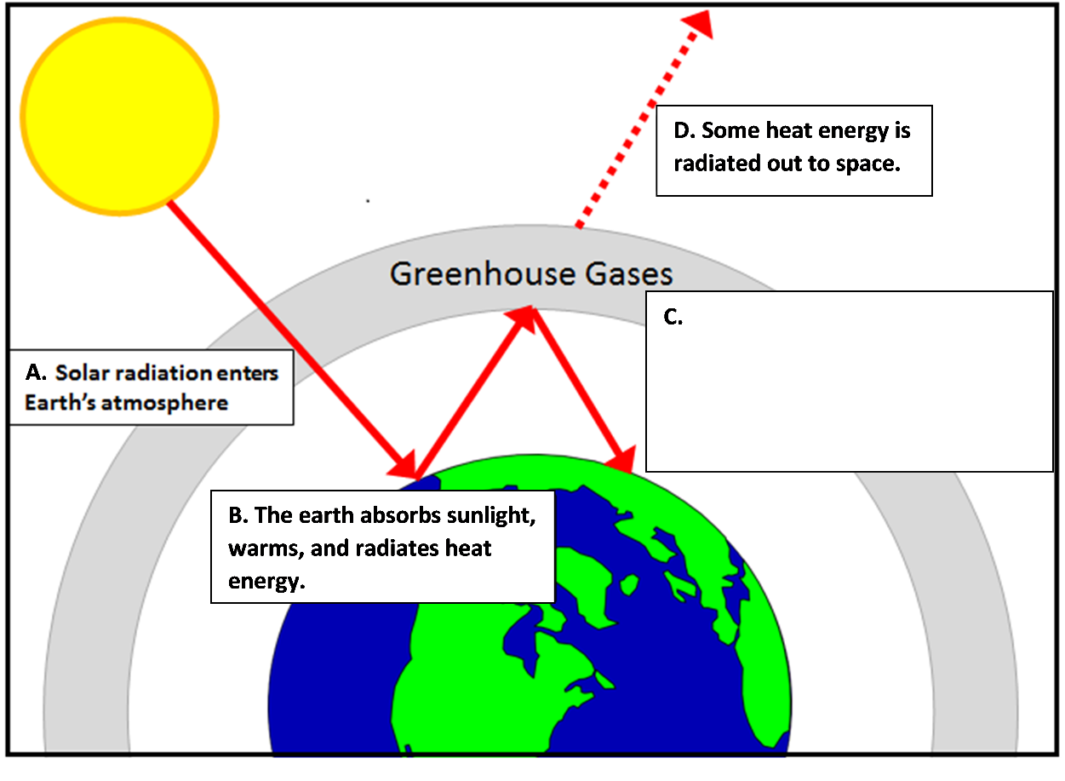

Nineteenth century scientists were able to predict future increases in global temperature, based on their understanding of the warming effects of CO₂ in the atmosphere. As scientists have learned more about all the factors that influence global temperature, their predictions of future temperature trends have become increasingly accurate.

6a. Scientists have used scientific data and computer models to estimate the contributions of multiple factors to trends in global temperature. View the animated graph, “How Global Warming Stacks Up” (https://climate.nasa.gov/climate_resources/144/). For each factor in this table, summarize how this factor has affected global temperature change since 1880.

Possible Cause of Change in Global Temperature | Effect on Global Temperature Trends
Changes in the earth’s orbit
Changes in the temperature of the sun
Volcanic eruptions
Forest replaced with types of land-use that reflect more light
Changes in ozone in the upper and lower atmosphere
Aerosol pollution
Greenhouse gases

6b. What do you conclude about the main cause of the increase in global temperature during the last century?

You may be wondering, “What’s all the fuss about a small increase in temperature (~1°C or ~2°F)?” One effect has been an increase in sea level, which has contributed to coastal flooding in some areas. Sea level has risen because melting glaciers have added more water to the oceans and because warming of the water in the oceans has increased the volume for a given amount of water. These effects will increase in the future as the effects of higher levels of greenhouse gases continue to warm the earth and the oceans continue to absorb heat. Long-term data and analyses indicate that sea level will rise enough to cause substantial flooding in many cities in the US (e.g. Miami, New York City) and around the world. Other effects of global warming have already been observed and are expected to increase in the future.
II. CO₂ and the Carbon Cycle
In this section you will learn about processes that influence the concentration of CO₂ in the atmosphere.

This figure shows a carbon cycle in nature. Carbon atoms cycle between CO₂ in the air and organic molecules in living organisms and dead organic matter.  7a. After CO₂ enters a plant (B arrow), how do the carbon atoms in CO₂ become carbon atoms in organic molecules in the plant? | 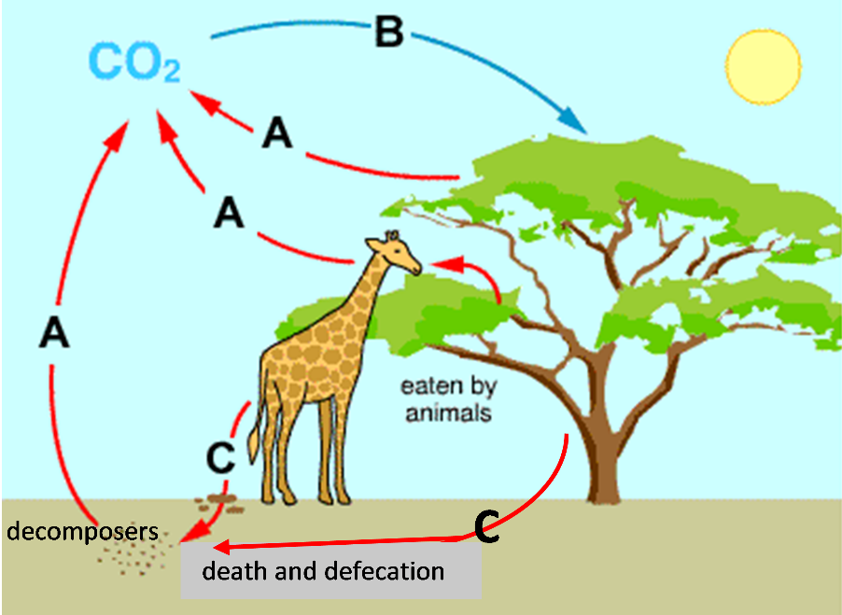

7b. Before CO₂ is released into the air (A arrows), how do the carbon atoms in organic molecules become carbon atoms in CO₂? How is this process useful for animals and plants?

7c. The giraffe weighs much less than the weight of all the food that the giraffe has ever eaten. What happened to all the weight of the food? Where did the atoms in the food molecules go?

8. Explain why the concentration of CO₂ in the atmosphere increases when humans burn forests to clear land for agriculture.

9. This figure shows a more complete carbon cycle. Use the information in this figure to explain how human activities have caused an increase in CO₂ concentration in the atmosphere.

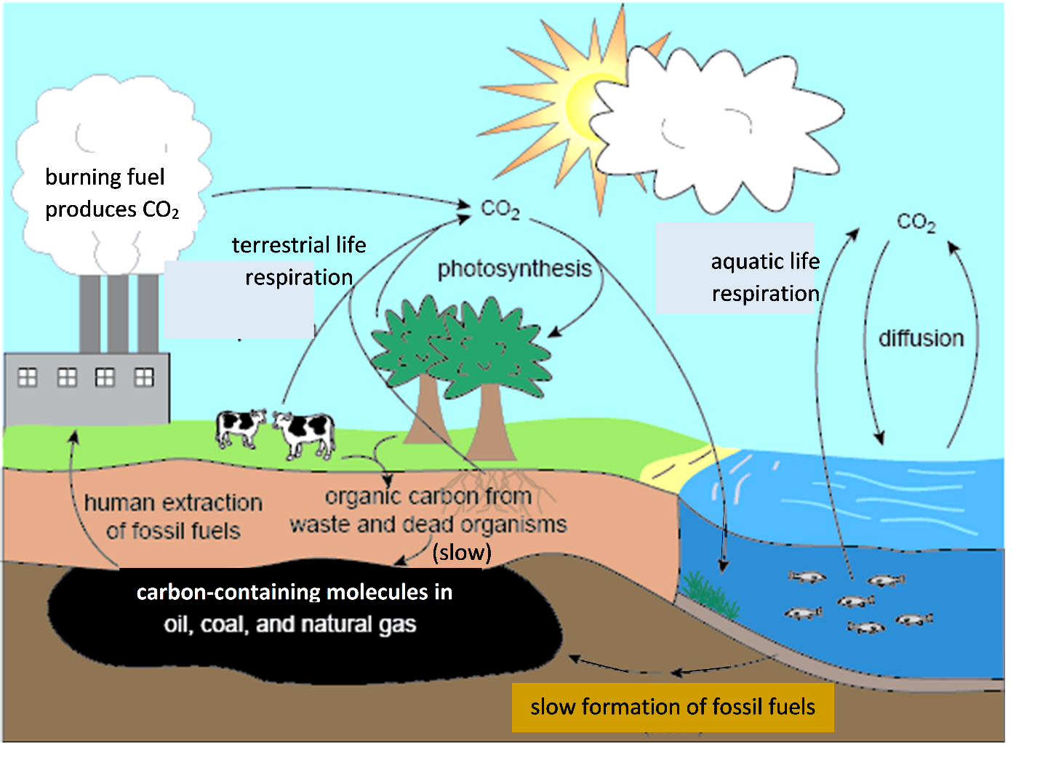

III. Food Production and Greenhouse Gases
Cellular respiration in farm animals and plants produces CO₂, but an equal amount of CO₂ is taken up by farm plants and used for photosynthesis. This is similar to a balanced carbon cycle in nature. However, other parts of modern food production contribute to increased CO₂ in the atmosphere.

10. Describe two ways that human activity contributes to increased CO₂ in the atmosphere.

A.

B.

