How to Graph in Science Name _____________________ # ____
Start Off with a Good Data Table
- Graphing Basics
- Make a title for the data table. The title of a table relates the independent variable to the dependent variable. This can be the same title as the experiment.
- Make a column for the independent variable on the LEFT and columns for the dependent variable on the RIGHT.
- Include labels for each variable.
- Write the units for each variable behind the subtitle.
- Include the number of trials that were conducted.
- If appropriate, include a column with an analysis statistics, such as an average, on the far right.
- Remember, trials are not your dependent variable!
Choose a Graph Style
1. Identify the independent and dependent variables.
- Remember, the scientist controls or manipulates the independent variable.
- Remember, the dependent variable depends on or responds to the independent variable.
2. Think about the independent variable. Is it qualitative or quantitative? If it is quantitative, is it continuous or discrete? Let's look at an example. Think about something specific, like a tiny Mini Cooper.
- Qualitative data is data that describes something.
  - The most popular color for Mini Coopers is red.
- Qualitative data can even be in the form of a number, but that number is subjective.
  - The 2013 Mini Cooper received a rating of 7.8 from U.S. News and World Report.
- Quantitative data is data that is numerical and objective. It can be continuous or discrete.
  - Continuous data is data that can take on any value in a range.
The volume of this Mini Cooper is 2152.08L.
  - Discrete data is data that can only have certain values.
The volume of this Mini Cooper is about 4 high schoolers (You can't have part of a student!). If the independent variable is quantitative and continuous, use a scatterplot graph with a line of best fit. If it is qualitative or discrete, choose a bar graph, line graph, or other type of graph.

How to Choose Which Type of Graph to Use?
From the National Center for Education Statistics
When to Use . . .
. . . a Line Graph.
Line graphs are used to track changes over short and long periods of time. When smaller changes exist, line graphs are better to use than bar graphs. Line graphs can also be used to compare changes over the same period of time for more than one group.
. . . a Pie Chart.
Pie charts are best to use when you are trying to compare parts of a whole. They do not show changes over time.
. . . a Bar Graph.
Bar graphs are used to compare things between different groups or to track changes over time. However, when trying to measure change over time, bar graphs are best when the changes are larger.
. . . an Area Graph.
Area graphs are very similar to line graphs. They can be used to track changes over time for one or more groups. Area graphs are good to use when you are tracking the changes in two or more related groups that make up one whole category (for example public and private groups).
. . . a Scatterplot Graph.
Scatterplot graphs are used to determine relationships between the two different things. The x-axis is used to measure one event (or variable) and the y-axis is used to measure the other. If both variables increase at the same time, they have a positive relationship. If one variable decreases while the other increases, they have a negative relationship. Sometimes the variables don't follow any pattern and have no relationship.

Scatterplot Graphs
Scatterplot graphs show possible correlation between the independent and dependent variable. We will use these graphs most often in science.
1. Title the graph. Be sure to include the independent and dependent variables in the title. A basic title would be "The Effect of (Change in Independent Variable) on (Dependent Variable)".
2. DRY MIX. (The dependent variable responds to the independent variable and is on the y-axis. The independent variable is the manipulated variable and it is on the x-axis.) Label the x-axis with the independent variable and the y-axis with the dependent variable. Remember to include the units for each in parentheses.
3. Space the values on each axis correctly. Determine the largest number you will have to graph for each variable. Count how many boxes you have to work with if you have graph paper. If you are drawing a graph on regular paper, measure how long each axis is. Use these values to figure out how to evenly space the numbers along the axis. Start at zero and write the numbers on each axis clearly. You do not have to label each box or space, just do enough to make your scale and intervals clear.
4. Plot the data. Carefully place a point on the graph for each ordered pair of data, just like in math class. There you would be given (X, Y) or a T-chart. In science class, each ordered pair is (Independent Variable, Dependent Variable) from the data table. If there is a lot of data, you may choose to graph a statistic, such as the average of all of the trials run for each independent variable value.
5. Draw the line of best fit. This is a line that indicates the general direction of the data. If the data points do not fall into a clear line, estimate their general direction and draw a line to show this. Check out the line's slope -- this is often very interesting data!

Data Example

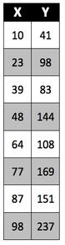 | - This is not a good data table, but it has enough information for us to graph it.  - The data table may remind you of the T-charts you see in math class listing the X and Y values of ordered pairs.  - Independent and dependent variables are ordered pairs, just like those in math class!  - This is why the independent variable goes on the X-axis and the dependent variable goes on the Y-axis.  How would you graph this data?  What story does this data tell?

This is a really bad graph...
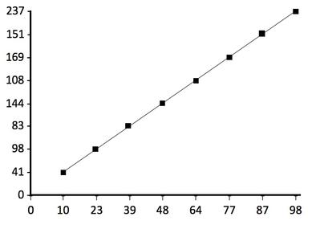 | Oh, boy, what isn't wrong with this graph?  - There is no title.  - There are no labels on the x- or y-axis. What are those numbers? Who knows?  - There are no units on the x- or y-axis. Is this a graph of speed in miles per hour or a graph of temperature in Kelvins? Who can tell?  - The data points are connected, but should they be?  - The line is completely straight. Science is all about the real world and the real world almost never gives us straight lines.
- Look at the numbers on the axes. These are the numbers from the data table, but they are not in numerical order and they do not divide the axes into even intervals.
- So many things wrong...I might have to cry.

This is also a bad graph...
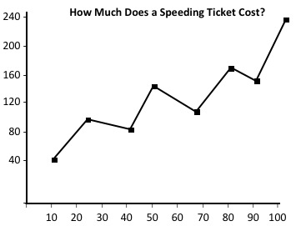 | This one looks better, but it is still not a good graph. Let's see what's wrong with this graph:  - There's a title, but it is not very informative. What's it a graph of? Who knows?  - There are still no labels on the x- or y-axis. What are those numbers? Who knows?  - Why does the y-axis apparently start below zero? And where is the zero on the x-axis?  - The data points are connect. Should they be?  - There are still no units on the x- or y-axis. Is this a graph of speed in miles per hour or a graph of temperature in Kelvins? Who can tell?
- Somebody played "connect the dots". This should be a nice straight line of best fit or a curve that tends to follow the points.
- I am not crying, but...

This is a good graph...

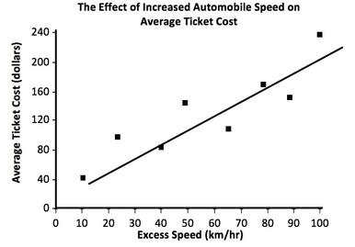 | This is such a beautiful graph!  - The title tells us both the independent variable and the dependent variable. We know what we are looking at.  - The axes are labeled correctly, including the units properly placed in the parentheses.  - The scales on both axes spread the graph out and are evenly spaced.  - Both axes start at zero.  - The data points are not connected. Instead, there is a line of best fit. This line shows that there is a possible correlation between the speed of an automobile and the cost of a ticket. The faster you go, the more you owe!
- This makes me so happy!!

