Name: __________________________________ Block _____ # ________
INVESTIGATION: REGULATORY SWITCHES OF THE PITX1 GENE IN STICKLEBACK FISH
(Modified from: HHMI Biointeractive) * Video link is on p.2
PART 1: INTRODUCTION
The types and amounts of proteins produced by a given cell in the body are very important and carefully regulated. Transcribing DNA to messenger RNA and translating that RNA to protein is often referred to as gene expression. Regulating that expression simply means turning on or off or increasing or decreasing the production of a given protein. Interestingly, protein production can be regulated at the translational and transcriptional steps, as well as after a protein is produced. In this activity, we will talk about how gene expression is regulated through transcription.
The basic elements of transcription regulation in eukaryotes are similar to the very well-studied lac and trp operon systems found in bacterial cells. In both eukaryotic and bacterial systems a protein, either an activator or repressor, binds to a region of the DNA called an “operator” in prokaryotes and a “regulatory switch” or “enhancer” in eukaryotes. The activator or repressor protein acts like the hand that flips the switch, but it can only turn the switch on or off if it can bind to the specific DNA sequence.
Gene regulation is essential for the cell to perform the functions needed to live. In multicellular eukaryotes, gene regulation is also important in building bodies. During development, different sets of genes need to be turned on and off in the right places, at the right times, and in the right sequence for bodies to be built correctly. In this activity, you will learn about one particular gene, Pitx1, and how its expression is regulated in different tissues.
Review Questions:
1. Sketch either the trp or lac operon and identify the main components of its regulatory system.

2. How is transcription related to gene expression?

3. Describe the difference between an operator and an enhancer.

PART 2: REVIEWING THE REGULATION OF EUKARYOTIC GENE TRANSCRIPTION
Watch the short film, The Making of the Fittest: Evolving Switches, Evolving Bodies. Pay close attention to how the switches regulate the expression of the Pitx1 gene in stickleback embryos.
Use the information from the film and your knowledge of eukaryotic gene transcription to answer questions 5-9.
4. Figure 1 is a diagram, similar to the one shown in the film (8:00-8:34), showing key components of gene transcription. Label the boxes in Figure 1 with the letters a-e, which correspond to the terms listed below. For example, write letter “a” in the box pointing at the protein-coding region.
a. Protein-coding region b. Regulatory switches (or enhancers) c. Promoter d. mRNA e. RNA polymerase
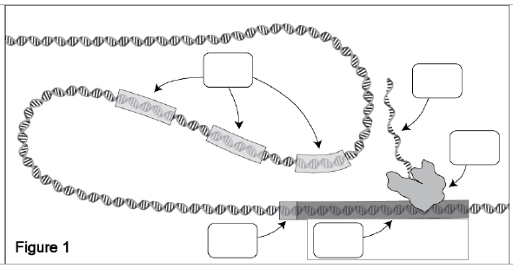

5. Gene transcription is a complex process that involves interactions of proteins and regulatory regions of DNA. Transcription factors specifically bind to the promoter to activate transcription. Other proteins play a role in these regulatory regions. Explain the role of each of the following, using the image to help you.
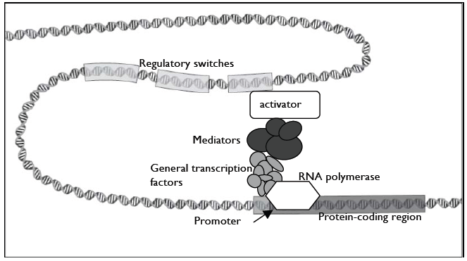
activators

enhancers

mediators

RNA polymerase

PART 3: GENE REGULATION IN DIFFERENT TISSUES
As you saw in the film, the presence or absence of pelvic spines in the stickleback fish is controlled by whether the Pitx1 gene is expressed in the pelvic tissue. However, the Pitx1 protein is actually important in building other body parts and is therefore expressed in multiple tissues at specific times.
How is Pitx1 expressed in different tissues? The Pitx1 gene has multiple regulatory switches that control the expression of the gene in different tissues: the pituitary, jaw, and pelvic tissues. Having multiple switches enables Pitx1 to be used many times in different contexts and expands the versatility of that gene. Activators present in a particular tissue bind to a specific sequence on the DNA and turn Pitx1 on in the appropriate tissues. For example, in the cells that develop into the pelvis there is a specific activator (activator 2) that binds to the pelvic switch to transcribe Pitx1 in that tissue. In the jaw, there is a different activator (activator 1) that binds to the jaw switch to turn on Pitx1 in the jaw tissue.
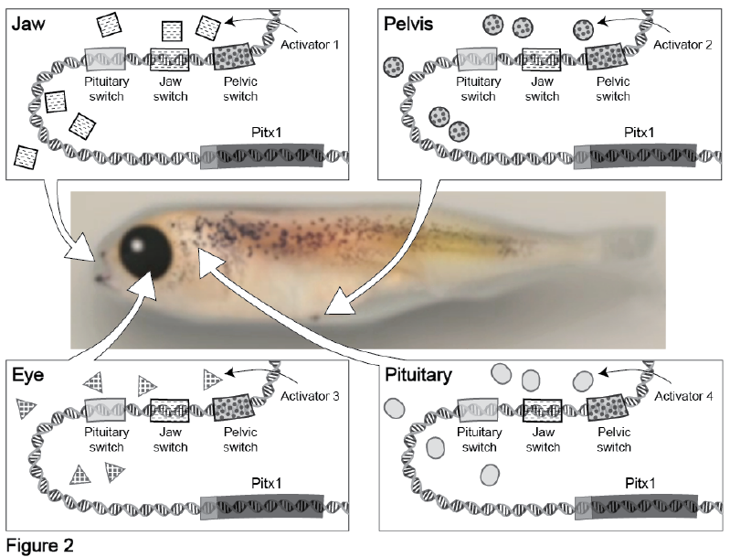
Figure 2 illustrates how Pitx1 transcription is regulated in different tissues. The center image is that of a stickleback embryo. The drawings in the surrounding boxes show the Pitx1 gene region and activator proteins present in the jaw, pelvis, eye, or pituitary tissues. Note that for simplicity, we are only showing one activator molecule present in a particular tissue. In reality, many activators are present in a particular tissue at any one time. Activator molecules with specific shading can bind to switches with the same shading.
6. List all the tissues shown in Figure 2 that express the Pitx1 gene:

7. Consider what was revealed in the film. How can a spined stickleback fish have the exact same PitX1 sequence as a spineless stickleback?

8. Examine the table, if a mutation occurred in the activator region, which areas would you expect to express the Pitx1 gene. Check all that would apply.
Mutation | Jaw | Eye | Pelvis | Pituitary
Activator 1
Activator 2
Activator 3
Activator 4

9. The Pitx1 protein has many important functions in various tissues during stickleback development. The complete absence of Pitx1 protein from all tissues is lethal to the organism. Circle the fish below that lacks Pitx1 expression in the pelvis and EXPLAIN your choice.

Synthesis Questions
10. Explain the role that regulatory switches play in determining whether stickleback embryos will develop pelvic spines.

11. According to the film, what is the selective pressure that led to freshwater stickleback fish losing their pelvic spines?

12. You isolate the DNA from the heart of the freshwater stickleback that lack pelvic spines. In the space provided below, draw what the Pitx1 gene region looks like in the heart tissue of that freshwater stickleback. Be sure to include the appropriate switches and Pitx1 coding region and label your drawing.

