Mag Bio Molecular Genetics (Mader Ch13-16) Review
1. Describe the contributions of each of the following with regards to the discovery of DNA:
Rosalind Franklin
Watson & Crick
Chargaff
Griffith (Avery)
Hershey-Chase
2. Know the structure of DNA; Nucleotide; Purine vs Pyrimidine; base pairing rules and the type of bond between bases. What is meant by semiconservative? Antiparallel?
Be able to label DNA or draw a model on the test. Be able to identify the 3' and the 5' ends
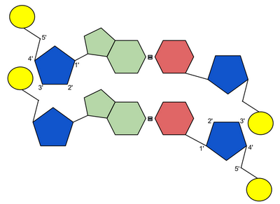
3. Describe the process of DNA replication (eukaryotes). Know the processes and ‘players’ involved: origins of replication, DNA helicase, SSB, DNA polymerase (you don’t have to differentiate between I and III), replication bubble and rep. fork, leading strand (continuous), lagging strand (discontinuous: Okazaki fragments), RNA primer (why is it needed?), primase, DNA ligase, complimentary strand, base-pairing (A-U). *Remember: daughter strands are laid down 5’ to 3’
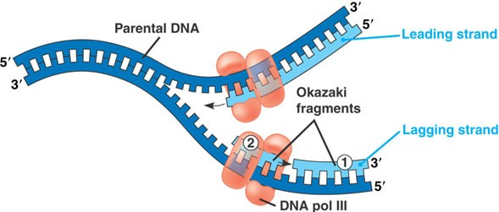
4. Describe the process of transcription, including where it occurs and what components are necessary for it to occur. Include: which strand of DNA is the template strand, Promoter, TATA box, RNA Poly, elongation (and base pairing), termination, eukaryotic editing (intron, exon), G cap, poly A tail
5. Describe the process of translation, including where it occurs and what components are involved in it. Pay particular attention to the role of tRNA and the anticodons. Know the sites of the large ribosome subunit (A, P, E) and how that mechanism works (See my PPt) . Also, be able to use a codon chart to determine the sequence of amino acids (peptide bonds) found in a gene.
6. Compare DNA to RNA; understand the roles of DNA polymerase and RNA polymerase.
7. Understand the relationship between genes, proteins, amino acids, and chromosomes. What is the “The Central Dogma”?
8. Prokaryotes: nucleoid region; circular c’some; only one point of origin; no introns; plasmids. Know the regions associated with a prokaryotic operon: Ex- Promoter, Operator, coding genes. Discuss the roles of each within the lac operon and trp operon. Which has an active repressor? Which is inactive? *Remember: The regulatory gene is outside of the operon and is always ‘on’. What does it synthesize?
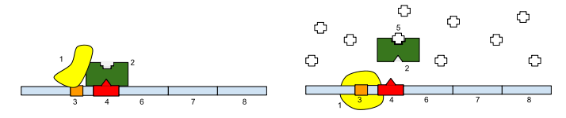

9. Review Mutations. Know point (substitution) mutations and the types (silent, missense, nonsense) vs. frameshift mutations. What is sickle cell?
10. Know these 2 eukaryotic regulation mechanisms (that affect transcription): 1) pre-mRNAmRNA (introns, exons, cap, tail); 2) euchromatin vs. heterochromatin (Barr bodies)- X chromosome inactivation. *This info is in the 3rd PPt (Gene Regulation)
11. Check the www.bozemanscience.com/biology videos that relate to the topics. Also, www.biologycorner.com has good animations of the processes
12. Review these topics in Biotechnology
- Cloning genes (Ex- transformation using restriction enzymes, bacterial plasmids, ligase). Go over the diagrams in Biotechnology PPt.
- Cloning organisms (Ex- Dolly)
- Recombinant DNA (Ex- Genetically Modified Organisms). Advantages? Disadvantages?
- DNA fingerprinting (Gel electrophoresis). How does the gel sort the fragments?
- PCR- What’s needed for copies to be made?
**another word for restriction enzyme is endonuclease

