Name ______________________________________ Block _______ # _________
Evolution by Natural Selection

I. What is evolution by natural selection?

A population of mice lived in a desert with gray sand. These drawings show how the population changed from time 1 to time 3.
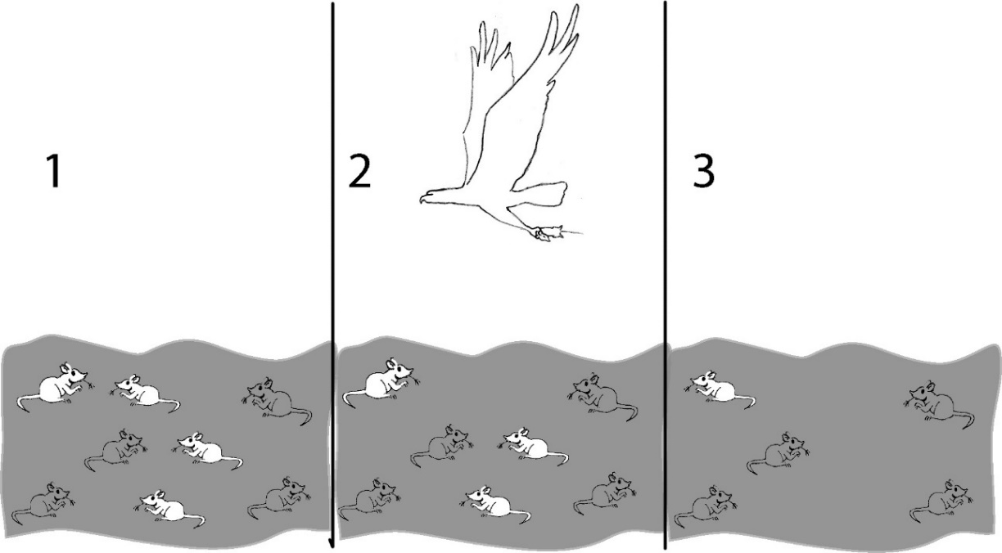

1a. Describe how the population of mice was different at time 3 compared to time 1. Explain what happened to cause this difference.

1b. Suppose the mice in drawing 3 had offspring. What color fur do you think most of the babies would have? Explain your reasoning.

Next, you will learn some vocabulary that is useful for analyzing how populations change and why.
- Evolution is defined as a change over time in the inherited characteristics of a population.
- Fitness is defined as the ability to survive and reproduce.

2. For the mice in the figure, which characteristic increased fitness?

3. The term fitness can have two different meanings, depending on what subject you are discussing.

a-What does the term fitness mean when biologists are discussing evolution?

b-What does the term physical fitness mean?

A biologist released three pairs of adult mice in a gray sand desert that did not have any other mice. These Generation 1 adults and their Generation 2 babies are shown in this chart. For the Generation 1 adults, 2/6 = 33% had gray fur. For the Generation 2 babies, 15/28 = 54% had gray fur.
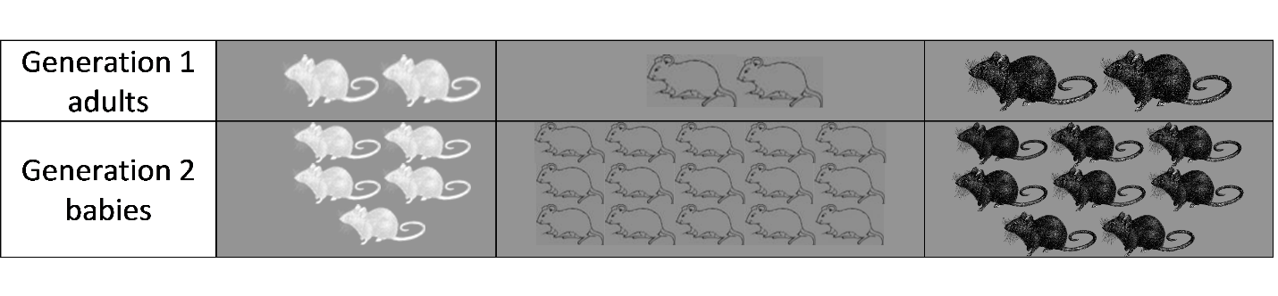
This table shows some characteristics of the Generation 1 female mice.

 | White Fur | Gray Fur | Black Fur
Running speed | 5 cm/sec. | 6 cm/sec. | 7 cm/sec.
Number of babies | 5 | 15 | 8
Age at death | 3 months | 6 months | 4 months

4. What do you think is the reason why the female mouse with gray fur had the most babies?

A characteristic which is influenced by genes and passed from parents to offspring is called a heritable trait. For example, fur color is a heritable trait for mice. An adaptation is a heritable trait that increases fitness.

5a. Which color fur is an adaptation for these mice? What evidence supports your answer?

5b. Explain why this adaptation was more common in the Generation 2 babies than in the Generation 1 adults.

6a. What do you think would happen to this population of mice after many generations on the gray sand?
- About half of the mice (54%) would have gray fur.
- Almost all of the mice would have gray fur.
- There would be equal numbers of mice with white fur, gray fur and black fur.

6b. Explain your reasoning for question 6a.

7a. Suppose that when the Generation 2 mice became adults, six of them migrated to a nearby desert with white sand. Which color fur would be an adaptation for the mice on the white sand?

7b. Is the same color fur an adaptation in all environments? yes __ no ___

7c. Suppose that the mice that migrated to the white sand included two black mice, two gray mice, and two white mice. What do you think the population of mice on the white sand would look like after many generations? Explain your reasoning.

In questions 4-7, you have seen that, over time, an adaptation becomes common in a population of mice. As you know, an adaptation is a heritable trait that increases fitness.

8. Explain why a trait that is heritable and increases fitness becomes common in a population of any type of animal or plant.

The process you described in your answer to question 8c is called natural selection. Due to
natural selection, an adaptation tends to become pre-dominant (common) in a population. *Note- this doesn’t mean that it is necessarily a dominant trait. A recessive trait in a population may be more common (ex: blood type O)

9. Examine the drawings on the next page. Explain how natural selection is occurring (use complete sentences and write in paragraph form)
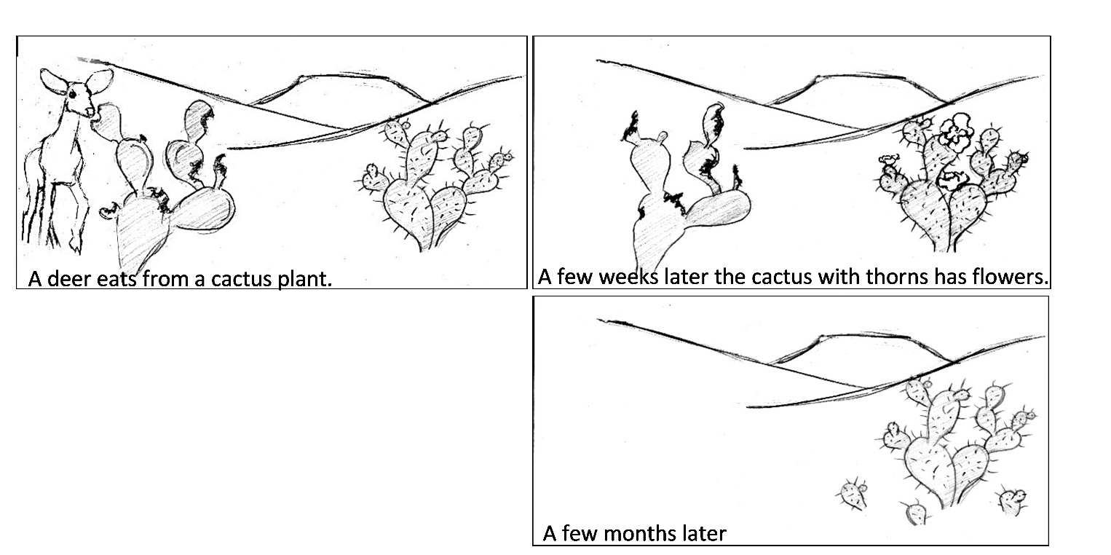

EXPLANATION:

