PHOTOSYNTHESIS REVIEW NAME_______________________________________ # ___________

- _______ Region(s) of the visible spectrum in which chlorophyll absorbs light very well is(are):
A) blue-violet region B) green region C) red region D) yellow region
- where does the energy of food originally come from? ____________________________
- When sunlight EXCITES / REDUCES electrons in chlorophyll in the photosystems, how do the electrons change?
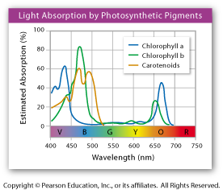

- Based on the graph to the right, what color of the visible spectrum is NOT absorbed by chlorophyll?
__________________________________

- _____________________________________ are autotrophs such as plants that depend on photosynthesis for both energy and carbon compounds.

Light Dependent Reactions
- Photosynthesis uses sunlight to convert water and carbon dioxide into
A) oxygen C) ATP and Oxygen
B) high energy sugars D) oxygen and high energy sugars
- How does NADP⁺ become NAPDH?

- Circle the letter of each sentence that is TRUE about the light dependent reactions.
- They convert ADP into ATP.
- They produce oxygen gas.
- They convert oxygen into carbon dioxide.
- They convert NADP⁺ into NAPRH.
- High energy electrons move through the electron transport system from PS I to PSII.
- Pigments in PSI use energy from light to reenergize electrons.
- High-energy electrons move through the electron transport chain.
- Pigments in photosystems II and I absorb light.
- ATP synthase helps H⁺ ions in the thylakoid space to pass through the membrane to the stroma.
- ATP and NADPH are used to produce high-energy sugars.
- How does ATP synthase produce ATP?

- The light reactions occur:
A) in the stroma
B) in the thylakoid
- The products of the light reactions of photosynthesis are ________________ , _____________ and __________________________________ .

Calvin Cycle (Light Independent Reactions)

- The Calvin Cycle takes place in the ______________________________ of chloroplasts.
- The Calvin Cycle uses ________________ and _________________, which are products of the light reactions of photosynthesis.
- The Calvin cycle begins by the attachment of CO₂ to RuBP by the enzyme________________.
- The Calvin Cycle functions to construct carbohydrates from carbon dioxide. True or False
- ______ Which of the following statements is true for the Calvin cycle?
A) it does not depend on sunlight to operate C)carbon dioxide is converted into H₂O and O₂
B) it turns glucose into CO2 D) it occurs in the nucleus of a cell
- The oxygen that is released as O₂ during photosynthesis came from ______________________ molecules.
- How many carbon atoms are in a molecule of glucose? _____________
- Which of the following statements about photosynthesis is true?
- the light-dependent reactions can occur only in the light, the light-independent reactions only in the dark
- photorespiration is more efficient at producing glucose than is photosynthesis
- the light-dependent reactions produce the energy-rich compounds that are used to run the light-independent reactions
- all of the above are true
- TRUE or FALSE CO₂ fixation occurs within the stroma. Circle answer.

- Light is required for the light dependent reactions because
- it is the source for electrons
- it splits the water molecule
- it energizes electrons in the reaction center
- it splits ATP molecules which generates the energy necessary to power the light independent reactions.
- None of the above
- What is the function of NADPH in the Calvin cycle?

- Circle the letter of each sentence that is TRUE about the light-independent reactions.
- The main products of the Calvin cycle are six carbon dioxide molecules.
- Carbon dioxide molecules enter the Calvin cycle from the atmosphere.
- Energy from ATP and high-energy electrons from NADPH are used to convert carbon molecules into higher-energy forms.
- The Calvin cycle uses 6 molecules of carbon dioxide to produce a single 6-carbon sugar molecule (C₆H₁₂O₆, glucose).
- ATP is produced in the light independent reactions
- ATP and NADPH from the light-dependent reactions are used in the Calvin cycle
- High energy sugar compounds are made from CO₂

- Use the following terms to fill in the diagram.
thylakoids Calvin cycle CO₂ NADP⁺
granum light NADPH O₂
stroma H₂O ATP ADP + P
light reactions sugar
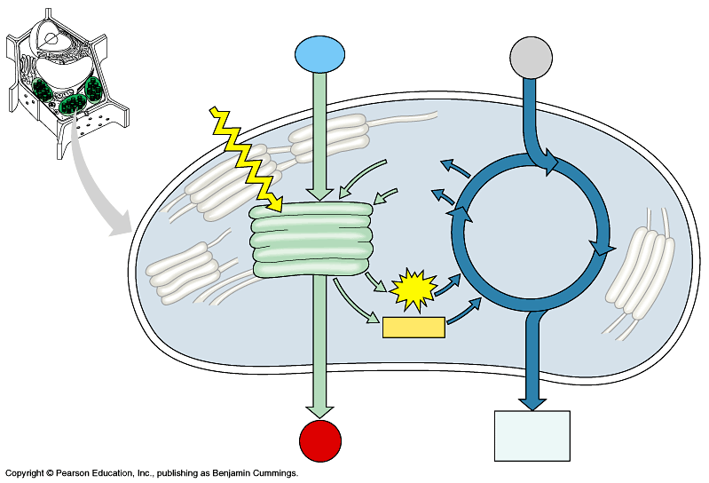
1.
2.
3.
5.
6.

11.
7. _____NADP⁺
8.
9.
10._
13. O₂
14.
4. stroma
12. thylakoid
General Information about Photosynthesis
- What color is not absorbed by chlorophyll? _______________________________________
- What is the function of chlorophyll?

- What is the balanced equation for photosynthesis?

- Complete the following chart for the comparison of light-dependent reactions and Calvin cycle.
 | LIGHT-DEPENDENT REACTIONS | CALVIN CYCLE
LOCATION

REACTANTS

PRODUCTS

IS LIGHT REQUIRED?

- Colors of light most useful in photosynthesis are
A) green, yellow and orange C) infrared, red and yellow
B) red, violet, and blue D) red, white and blue
- During what stage of photosynthesis are ATP and NADPH converted BACK to ADP + Pi and NADP⁺?
A) the light-dependent reactions C) both A + B
B) the light-independent reactions D) Neither A nor B
- During photosynthesis, photons raise electrons to higher energy levels. These excited electrons belong to what compound?
A) H₂O B) ATP C) RuBP D) glucose E) chlorophyll
- Which uses the most ATP molecules? Light reactions or Calvin Cycle Circle answer.

- Three students are investigating the effects of light intensity on photosynthesis by the aquatic plant Elodea. They varied the light intensity by placing a lamp at 5 different distances from the aquarium. The students left the room lights on and the window shades up. Then they measured how much O₂ the plant produced per hour at the different lamp distances. Here is their data table.
Rate of Photosynthesis in Elodea
Lamp distance (cm) | 15 | 30 | 45 | 60 | 75
O₂ gas produced (mL/hr) | 7.25 | 6.25 | 5.0 | 4.5 | 4.5

- Use the data to make a graph.

- At which lamp distance(s) is photosynthesis occurring at the fastest rate?
- At which lamp distance (s) is photosynthesis occurring at the slowest rate?
- The students designed the experiment to test this hypothesis: If the lamp is closer to the aquarium, then photosynthesis will occur faster. Do their results support their hypothesis? Why or why not?

Use the following graphs for questions 12 and 13
- EFFECT OF TEMPERATURE: The chemical reactions of photosynthesis require enzymes (proteins) to make them happen. Enzymes work best in a certain temperature range. At temperatures on either side of this optimum range, photosynthesis will slow or stop. Which of these graphs represents the effect of temperature on the rate of photosynthesis? Why?

- EFFECT OF LIGHT: The light dependent reactions of photosynthesis require light. As light intensity increases, photosynthesis will also increase up to a point where the enzymes are working as fast as they can, all the carriers are full and cycling as quickly as they can, and photosynthesis can’t go any faster. Which of these graphs represents the effect of light intensity on the rate of photosynthesis? Why?

