Taxonomic Group | Members
Genus
Family
Order
Class
Phylogenetic Trees Worksheet Name _____________________________ Block ____ #______
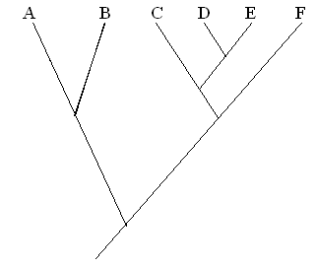
1. Identify which species could belong together in each of the following taxonomic groups in the table above
1b. A student argues B, C and D represent a family, because they are closely related on the tree. Do you agree? Why or why not? Is this monophyletic, polyphyletic or paraphyletic? Explain

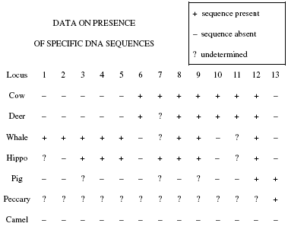
2. Two hypotheses have been produced on the relationship of several mammal species. They are shown below. Identify 3 pieces of specific evidence that could be discovered to determine which tree is more accurate.
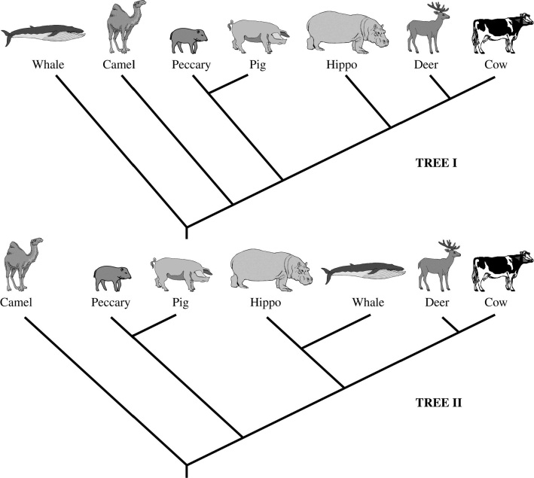
The data to the right was discovered. Which tree is supported? Explain

3. Use the following data on # of DNA nucleotide differences in the hemoglobin gene to draw a phylogenetic tree:
 | Panda | Grizzly Bear | Polar Bear | Black Bear | Andean Bear | Raccoon | Red Panda
Panda | x | 24 | 23 | 26 | 27 | 30 | 30
Grizzly Bear | X | x | 4 | 7 | 14 | 29 | 29
Polar Bear | X | X | x | 8 | 13 | 30 | 30
Black Bear | X | X | X | x | 14 | 31 | 30
Andean Bear | X | X | x | x | X | 30 | 31
Raccoon | X | X | X | X | X | X | 15

4. Use the following data on morphological features to build a phylogenetic tree
 | Rose bush | Pine Tree | Ginkgo | Moss | Algae | Corn | Liverwort | Fern
Flowers? | Y | N | N | N | N | Y | N | N
Seeds? | Y | Y | Y | N | N | Y | N | N
Xylem? | Y | Y | Y | N | N | Y | N | Y
Terrestrial? | Y | Y | Y | Y | N | Y | Y | Y
Dicotyledon? | Y | N | N | N | N | N | N | N

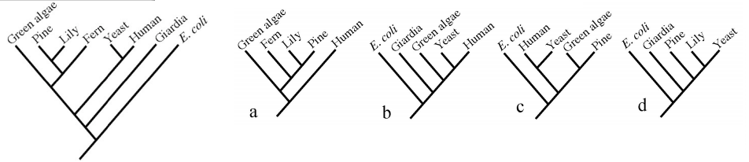
Which tree to the right is consistent with the tree on the left?

