Biochem HW Name__________________________________
Chapter 15: Stereocenters:R,S designation Block____________ #___________

- Identify all of the asymmetric centers in the following compounds and then indicate how many stereoisomers are possible (2^{n}).

- Rank the following groups in order of decreasing priority (1 = highest, 4 = lowest).
- –F, -NH₂, -CH₃, -OH

- –NH₂, -CH₂NH₂, -CH₃, -CH₂NHCH₃

- –COOH, -CH₂OH, -H, -CHO

- In the R,S system, which of the following groups has highest priority?
a. alkyl b. amino c. hydroxyl d. thiol

- Which of these are R and which are S?

 | 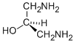
. | 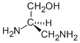

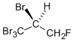

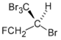

- What are the R/S configurations at the following stereocenters?

