Reference for Hair Lab:
- Follow the directions carefully for the “Mini” Hair Lab given Friday (can also be found on blog)
- You must make slides of 2 different human hairs (preferably different ‘types’) and at least 2 other different animals. You must also make scale casts (with latex or clear polish…I showed you how on Friday) for each, so there will be 8 total drawings IN PENCIL. (Read the lab directions!). Must label characteristics on EACH DRAWING, using a ruler (OR POINTS OFF!).
- Here are examples of some characteristics that should be labeled on drawings of the actual hairs:
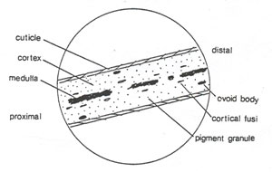

*Be sure and note if the medulla is continuous, fragmented, intermittent, absent, etc
Found this on-line and added some notes of my own. This may help for scale cast identification and labeling:
The cuticle is made up of overlapping plates or scales of keratin arrayed in characteristic patterns. Although these scale patterns may be visible on a wet-mounted specimen at high magnification, it is often difficult or impossible to discern the scale pattern if the refractive index of the scales is very close to that of the mounting fluid. One way around this problem is to make a cast of the exterior surface of the hair and examine that cast under high magnification.
Figure 6-7 shows the three major types of scale patterns. The imbricate scale pattern is a flattened wavy pattern that is commonly found on human hair and many types of animal hair. The coronal scale pattern is a crown-like pattern that resembles a stack of paper cups, and is normally found only on very fine hair. Coronal scales are found on many types of animal hair and are very rarely present on human hair. The spinous scale pattern is a petal-like pattern made up of triangular scales that protrude from the cuticle. Spinous scales are found in the proximal (root) region of the fur hair of some animals, including bobcat, chinchilla, fox, lynx, mink, mouse, otter, raccoon, rat, sable, sable, seal, and sea lion. Spinous scales are never found in human hair.
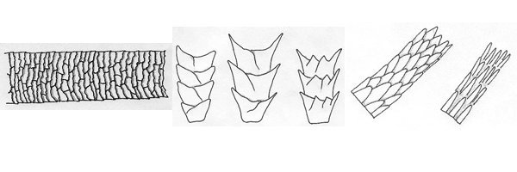
Figure 6-7. Imbricate, coronal, and spinous scale patterns (left to right)
Although scale patterns are seldom useful for characterizing human hair specimens, they are important for discriminating human hair from animal hair and for determining the type of animal from which a specimen originated. For much more information about scale patterns, read Microscopy of Hair Part II: A Practical Guide and Manual for Animal Hairs, Forensic Science Communications, July 2004, Volume 6, Number 3.
In this lab session, we’ll make scale casts using ordinary colorless nail polish as a casting medium, the same method used by professional forensics labs.
Required Equipment and Supplies
- goggles, gloves, and protective clothing
- compound microscope
- forceps or tweezers
- microscope slides (as required)
- nail polish (colorless) or latex
- nail polish remover or acetone *Note from Mrs. Phillips: *DON’T DO THIS! Either label each slide with your initials (sharpie) and put them on the back table for reference in CSI, or throw in broken glass container when done.
- human hair specimens

Procedure
- Brush a thin layer of clear nail polish onto the middle third of a microscope slide, or put a thin line of latex on the end of a slide and evenly ‘drag’ it across the length of the slide, using another slide to ‘drag’ it.
- Carefully press the hair specimen into the tacky nail polish or latex until it adheres. Leave some of the distal end of the hair shaft ‘hanging off’ the slide. *Root end (proximal) should be ON the slide
- While waiting for it to dry, put slide under m’scope and make drawings of the actual hair. Label structures, using a ruler
- Allow the nail polish (or latex) to dry.
- Using forceps (or fingers), carefully pull the hair specimen away from the slide in one smooth motion.
- Examine the scale cast under high magnification (*NOTE FROM PHILLIPS: always start on scan- 40X, then go to low power- 100x, then go to high power- 400x. ONLY USE THE COARSE ADJUSTMENT KNOB ON SCAN! If you use it on higher powers you will BREAK THE SLIDE AND SCRATCH THE LENS)! Once you go to low power and high power, ONLY USE FINE ADJUSTMENT KNOB TO FOCUS. Also, adjust the diaphragm and lamp settings each time you change the magnification. Also, do NOT click in the longest objective, which is the oil immersion one. SLIDE WILL BREAK!). Repeat steps 1 through 6 for each of your hair specimens.
- If you have the necessary equipment, take a picture for reference (or label the slides with your initials and keep the slides). Also, make a sketch (label the scale cast pattern) on lab sheet. Write observations and descriptions
Figure 6-8. Using forceps to remove the hair specimen from the dried nail polish
Scale casts may last for several days to several months, depending on how they are stored. High temperature and high humidity reduce the useful lifetime of such casts. When you are finished using a cast, you can use nail polish remover or acetone to clean the nail polish from the slide.
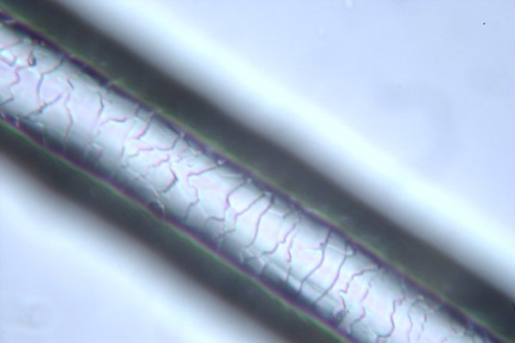
Table 6-4. Make Scale Casts of Hair specimens – observed data
# | Observations
1
2
3
4
5

Review Questions
Q1: The presence of which of the three scale patterns rules out a hair specimen as human?
Q2: What is the primary forensic value of determining the scale pattern on a hair specimen?

