Reflex Arc & Reflexes Lab Name ____________________ # ____

Section 1: What is a reflex?

Quick answer: a quick movement that occurs in response to something before you even realize you are moving.
Alternative answer: a local motor response to a local sensation.
When the doctor taps on your knee, you respond by kicking your leg. This occurs quickly, before you even realize that you did it. Another reflex is pulling your hand away from a painful or hot or freezing item quickly, before realizing you did it. Another is blinking when something touches your eye. And gagging when you something is placed down your throat (like the doctor telling you to say "ah" while he/she shoves a popsicle stick into the back of your mouth). All of these reflexes are motor responses to sensory information... where the movement is of the same body region that sensed the stimulus.
You will see that these reflexes occur because the sensory neurons that bring the stimulus information into the spinal cord synapse directly or nearly directly onto motor neurons located in that area of the spinal cord that the sensory neurons entered.
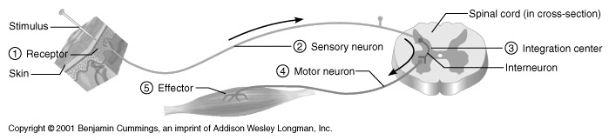
Reflex arcs have five essential components:
1. The receptor at the end of a sensory neuron reacts to a stimulus. For example, some receptors in
the skin are sensitive to heat, others to pressure.
2. The sensory neuron conducts nerve impulses along an afferent pathway towards the CNS.
3. The integration center consists of one or more synapses in the CNS.
4. A motor neuron conducts a nerve impulse along an efferent pathway from the integration center to
an effector.
5. An effector responds to the efferent impulses by contracting (if the effector is a muscle fiber) or
secreting a product (if the effector is a gland).

Section 2: Types of Reflexes

Reflexes can be categorized as either autonomic or somatic. Autonomic reflexes are not subject to conscious control, are mediated by the autonomic division of the nervous system, and usually involve the activation of smooth muscle, cardiac muscle, and glands. Somatic reflexes involve stimulation of skeletal muscles by the somatic division of the nervous system.
Reflexes can also be categorized according to the number of synapses they make. If the sensory neuron (SN) comes in and directly synapses on the motor neuron (MN) that is called a monosynaptic reflex. Monosynaptic means "one synapse". So, in the monosynaptic reflex, there is only one synapse that occurs in the spinal cord: SN -----< MN (the line with the "<" represents an axon with axon terminals). This reflex is quick; it only takes as long to respond as it takes for the sensory neuron to carry the information to the spinal cord, cross the synapse to the motor neuron, run back out the motor neuron axon to the muscle, and cause contraction. Not even one second is necessary.
A disynaptic reflex requires that one interneuron be interposed between the sensory neuron and motor neuron (SN -----< IN -----< MN). A polysynaptic reflex has more than two synapses in the spinal cord (SN -----< IN -----< IN -----< MN). The disynaptic and polysynaptic reflexes are the most common.
Section 3: Importance of Reflex Testing
Reflex testing is an important diagnostic tool for assessing the condition of the nervous system. Distorted, exaggerated, or absent reflex responses may indicate degeneration or pathology of portions of the nervous system, often before other signs are apparent.
If the spinal cord is damaged, then reflex tests can help determine the area of injury. For example, motor nerves above an injured area may be unaffected, whereas motor nerves at or below the damaged area may be unable to perform the usual reflex activities.
Closed head injuries, such as bleeding in or around the brain, may be diagnosed by reflex testing. For example, the oculomotor neuron stimulates the muscles in and around the eyes. If the pressure increases in the cranium (such as from an increase in blood volume due to brain bleeding), then the pressure exerted on the Cranial Nerve III may cause variations in the eye reflex responses.
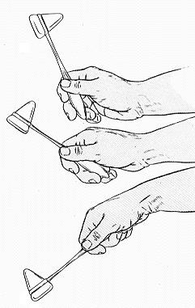
Section 4: Testing Stretch Reflexes
The primary tool used to test reflex activity is the Taylor Reflex Hammer. Care must be taken to use the proper hammer technique during our lab activities. Improper techniques will not elicit the desired reflexes. The tap stretches a muscle, which stimulates stretch receptors located in the muscle. In response to the increased stretch, which normally would only occur when the muscle load has suddenly increased, the muscle contracts. In normal circumstances the stretch reflex allows muscles to reflexively increase the strength of contraction in response to increased load.
A. Knee-Jerk Reflex (monosynaptic) -
The knee-jerk reflex is called that because it is a reflex most commonly tested by tapping on the patellar tendon and seeing if the leg kicks out, or jerks, in response. In actuality, this particular test is a hard one to start off explaining, so lets look at a different example of the same type of reflex.
In order to understand this reflex at all, we need to understand proprioception. Proprioception is the awareness of your body's position in space. Even with your eyes closed, you know where your hands and arms and legs are. Are your hands in your pockets or on your lap? Are your legs crossed or uncrossed?

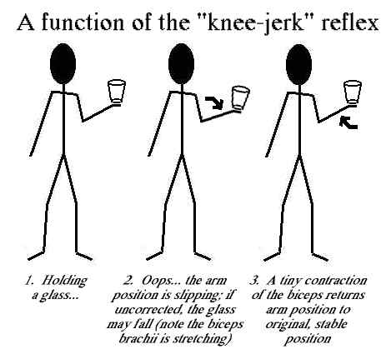
How do we sense this? One way we do it is by using sensory neurons that have their dendrites embedded within special muscle fibers within your skeletal muscles, called muscle spindles. When your muscles change length that excites the dendrites of these proprioceptive sensory neurons within the muscle spindles. Consider your biceps brachii muscle for a moment. As your elbow extends, this muscle stretches. And as your elbow flexes, biceps brachii shortens. Using stick figures, here’s a scenario that involves muscle spindles embedded within the biceps brachii muscle.
As this stick figure holds a cup steadily, the biceps brachii doesn't change length. But, no one can hold a cup perfectly still... with time, the arm may extend a teeny bit at the elbow. This is unintentional. But, if it were to go uncorrected, the stick figure might spill the liquid from the cup.
Luckily, as the arm extends, even just a teeny bit, the biceps brachii stretches a teeny bit. This stretch activates the muscle spindle sensory neurons, and they send this sensory information into the spinal cord to cause a correcting movement-- a small contraction of the biceps brachii. This tiny contraction is all that is needed to restore arm position.
Therefore, you can think of the knee-jerk reflex as a correctional system. Any deviations from planned movements (in the figure above, the planned movement was to remain still) will be corrected for.
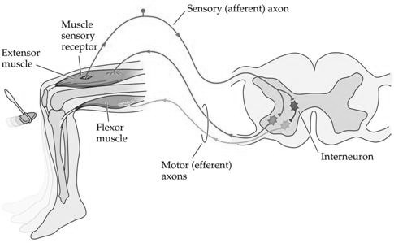
Note that this type of movement should be a reflex, since we do not need to involve our brains in correcting every deviation from planned movements. It is handy that the spinal cord can take care of this for us. Could you imagine if you had to think about every movement all the time-- we would never have room for other, higher thoughts to occur at the same time as we moved around! Yikes.
What would this reflex look like in terms of cellular components within our nervous systems?
The sensory neuron brings the information from the muscle spindle into the spinal cord. The SN axon synapses directly on motor neurons that innervate the muscle containing the muscle spindle. So, if the SN brought in information from spindles within the quadriceps muscle, it would synapse directly on quadriceps MNs. This monosynaptic connection is the knee-jerk reflex. The result would be contraction of the quadriceps muscle.
Of course, if you try to contract your quadriceps at the same time that your hamstring is active, you won't get any movement. Right? When antagonists are active together, that stabilizes position, making it more rigid. What we want to do is to correct the position... that's why there's a bit more to this reflex than just the SN and the MN.
Now look at the other part of this diagram. The SN sends its information to an interneuron (IN) within the spinal cord as well. These INs synapse onto MNs that innervate antagonists (in this case the hamstring). And, these synapses are inhibitory. If the SN brings information from the quadricpes muscle spindle into the spinal cord, it synapses on an interneuron which inhibits the hamstring muscle. If we have to flex at the knee, we need to turn off the hamstring muscle so that it doesn't oppose the knee flexion (the hamstring wants to extend the leg). This second half of the knee-jerk reflex is disynaptic.
How come when the doctor taps your patellar tendon you kick in response? The patellar tendon is a tendon of the quadriceps muscle group. The quadriceps muscles all work to extend the knee. The tap on the tendon is an artificially-induced stretching of the quadriceps muscles. The quadriceps muscle spindles then sense that the muscles have been stretched (which would normally mean that the knee has flexed). The SNs from the spindles of the quadriceps muscles bring this information back to the spinal cord to cause the quadriceps muscles to contract (and to relax the hamstring muscles). The result: a kick.
Knee-jerk Reflex: Have your lab partner sit on a table with their legs relaxed and hanging freely over the edge without touching the floor. Gently strike your partner’s patellar ligament (just below the patella) with the blunt side of a rubber percussion hammer. The normal response is a moderate extension (kick) of the leg at the knee joint.
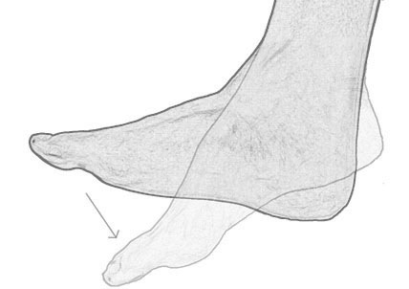
Several other reflexes are similar to the knee-jerk reflex and stimulate stretch receptors. Let’s test a couple more!
Ankle-jerk Reflex: Have your partner kneel on a chair with back toward you and with feet over the edge and relaxed. Gently strike the calcaneal tendon (just above its insertion on the calcaneus) with the blunt side of the rubber hammer. The normal response is plantar flexion of the foot.
Biceps-jerk Reflex: Have your partner place a bare arm bent 90° at the elbow on the table. Press your thumb on the inside of the elbow over the tendon of the biceps brachii, and gently strike your thumb with the rubber hammer. Watch the biceps brachii for a response. The response might be a slight twitch or flexion (my, what BIG muscles you have!) of the forearm at the elbow joint.
MAKE SURE TO COMPLETE YOUR LAB REPORT!

Reflex Lab Report Name(s): _____________________________
Section 1: What is a reflex?
Draw a typical reflex arc and label the 5 components.
Section 2: Types of Reflexes
1. What is the difference between autonomic and somatic reflexes?

2. Diagram the neurons involved in monosynaptic, disynaptic, and polysynaptic reflexes.
a. monosynaptic –
b. disynaptic –
c. polysynaptic –
Section 4: Testing Stretch Reflexes
3. What is proprioception?

4. Explain the knee-jerk reaction in terms of the neurons needed to complete the reflex. Why is it considered monosynaptic?

5. Complete Data Table 1.
Reflex | Result (Was there a response? What was it?)
 | Partner 1 | Partner 2
Knee-jerk Reflex
Ankle-jerk Reflex
Biceps-jerk
Analysis & Conclusions
1. Name and describe 3 advantages of have reflex reactions.

2. Newborns often have different reflexes than adults. Why might a newborn’s reflexes differ?

