Name ____________________________________ # _______
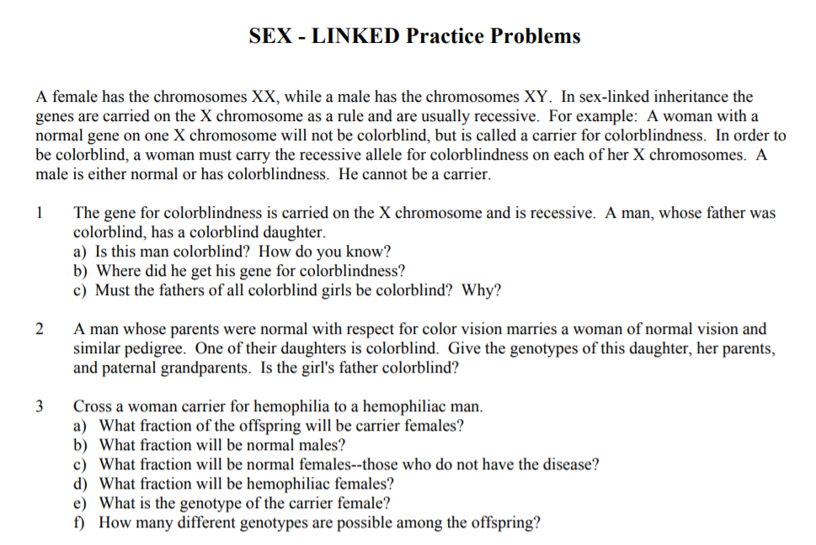
4.
5.

