AP Bio: Intro to Statistics Name_______________________________
Summer Assignment

The following assignments are due the FIRST DAY of the semester. There will be a quiz over these concepts during the first few days of class. *If you have a hard copy of this assignment and can’t access the below links, you can find everything on my blog: www.phillipsscientificmethods.weebly.com.

INTRO TO STATISTICS:
A. Watch the following videos. Take notes in your composition notebook and answer the following questions directly on this sheet. You must be able to APPLY and/or ANALYZE data on most EVERY assignment throughout this course based on these principles, concepts and practices:
1. Bozeman- Types of Graphs (*MUST know when to use each type appropriately!)
a. What type of graph uses a ‘best fit’ line?
b. Explain the difference in a bar graph and a histogram.

c. What type of graph shows a change over time?
d. What type of graph displays a correlation of variables?
1. Distinguish between the independent variable and dependent variable and where they are placed on a graph.

e. Which type of graph is best for comparing 2 or more different groups?
f. Which type of graph is better for showing distribution of data?

g. Explain when a pie graph should be used and give (draw) any example.

h. State at least 5 elements that any graph should always display.

i. Watch ‘Graphing Data by Spreadsheet’. Bookmark it and take notes in your notebook for reference. Also, watch ‘Graphing Data by Hand’, if needed.
2. Bozeman- Statistics for Science
a. What is n?
b. What is x (bar)?
c. What is M?
d. What was the range of the sample he gave?
e. Explain ‘Degrees of Freedom’ (with any example) and why the formula is n-1.

3. Bozeman- Standard Deviation
a. What is meant by normal distribution?

b. What does standard deviation (SD) measure?

c. Can 2 sets of data have the same mean but a different SD? Explain.

d. 1 SD means ______% of the population falls within this range; while 2 SD means _____% falls in this range.
e. Pause the video and calculate the SD from the 2nd set of data given BY HAND. Show your work.

f. Take notes as to how to solve for SD using Excel. You may want to bookmark the video for quick reference for labs we will be doing throughout the course. *Note- The AP Bio Exam only allows you to use a BASIC 4 function (with square root) calculator, so make sure you learn to solve it by hand!
3. Bozeman- Standard Error and Kevin Piers Standard Deviation & Standard Error of Mean
a. From Bozeman: Explain the significance of standard error among 2 different sets of data with different sample sizes that have the same Mean (in terms of precision).

b. From Piers:
1- What do SEM bars that have overlapping Means on a graph indicate?

2- Explain the significance if SEM bars overlap, but the Means do not overlap.

3- Explain the significance if there is no overlap between SEM bars.

c. From Bozeman-As stated earlier, make notes (notebook) for calculating & using Excel. Use the example he gave and try it yourself!
4. Go to www.Bozemanscience.com/ap-biology/. Watch the videos on AP Biology Practices. TAKE NOTES IN YOUR COMPOSITION NOTEBOOK!
B. Go over this Power Point. Make sure you can work all examples on your own (use your notebook)
C. *If additional review is needed, there are some other recommended sites on my blog. One good site is www.mathisfun.com.

*SEE NEXT PAGE FOR PROBLEMS TO SOLVE

D. Solve the following problems IN PENCIL. You must show ALL WORK. Make sure graphs have Titles and are properly labeled WITH UNITS: (Click here for AP Bio Formulas Sheet)
1. Graph the following sample data set showing the number of leaf disks that rise in a solution over time as photosynthesis occurs.
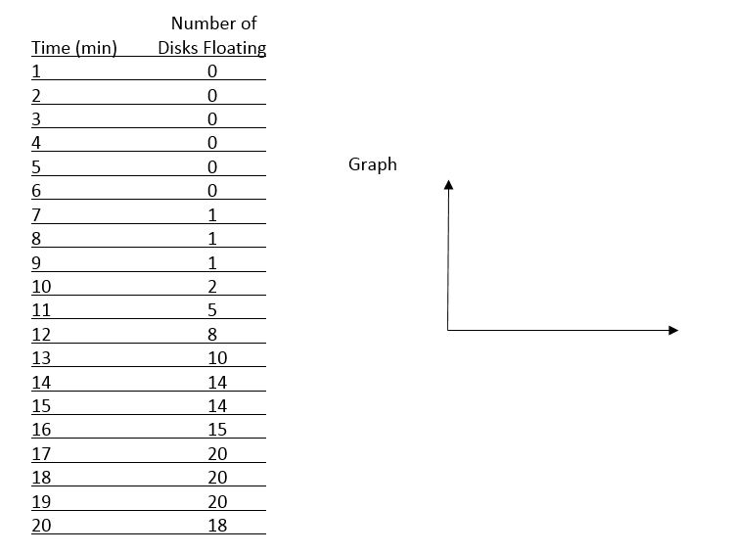

2. A- Calculate the mean and standard deviation for the data set of annual monthly rainfall. B- Use the data to sketch the appropriate type of graph.
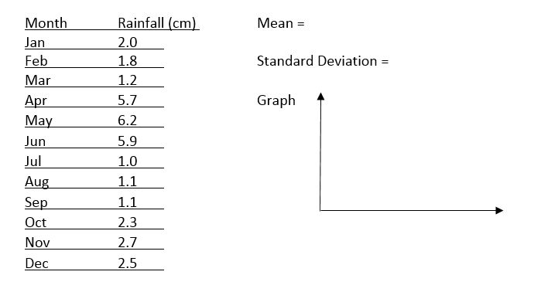

3. Below are 2 samples of data that were collected
(*we will ignore Units & Graph Title for this one):
Sample A: 12, 13, 14, 15, 16, 17, 18
Sample B: 10, 15, 20
Calculate the mean for Sample A ________
Calculate the mean for Sample B ________
Are the calculated means sufficient in explaining the data? Why or why not? (*Be specific!)

Calculate:
SD for Sample A _________
SD for Sample B ___________
Explain the significance of the results.

Calculate the Standard Error of Mean for Sample A _______
Calculate the SEM for Sample B _______
Graph your results, showing error bars for each.
Do the bars overlap?
Do the means overlap?
Explain whether or not there are ‘significant’ differences between the 2 populations.

4. A student noticed that the ivy leaves growing on the shady side of a building were larger than ivy leaves growing on the sunny side of the same building. The student collected and measured the maximum width, in centimeters, of 30 leaves from each habitat. Use statistical analysis to determine if it’s likely that there is a significant difference in leaf size between the shady and sunny ivy plants with 95% confidence (±2 SE). Graph the data and indicate error bars. (*see next page)
Calculated Results (from collected data): 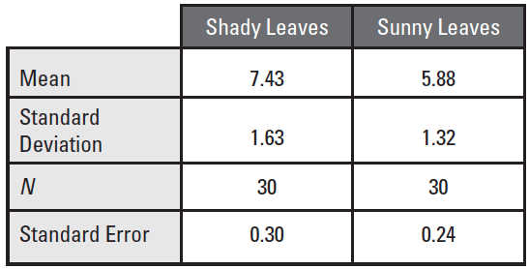

Using the data given and constructed graph, justify the significance between the two samples.

