Biochem- Chirality HW Name__________________________________
Chap 15: Stereocenters: R,S designation Block____________ #___________
Use your text & PPt to complete the following. *Refer to Section 15.3 & Example 15.4 to do #1.
- Identify all asymmetric centers in the following compounds and then indicate how many stereoisomers are possible (2^{n}).

- Rank the following groups in order of decreasing priority (1 = highest, 4 = lowest).
- –F, -NH₂, -CH₃, -OH

- –NH₂, -CH₂NH₂, -CH₃, -CH₂NHCH₃

- –COOH, -CH₂OH, -H, -CHO

- In the R, S system, which of the following functional groups has highest priority?
- alkyl b. amino c. hydroxyl d. thiol

- Which of these are R and which are S?

 | 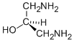
. | 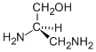

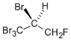

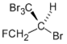

- What are the R/S configurations at the following stereocenters?

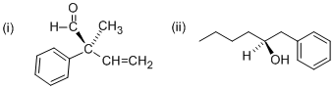

- Refer to Example 15.4 in text
  - What is a diastereomer?

  - Problem 15.4:
    - Which are pairs of enantiomers?

    - Which are diastereomers?

