Topic Review Guide- Plant & Animal Defenses Name ___________________________ # ____
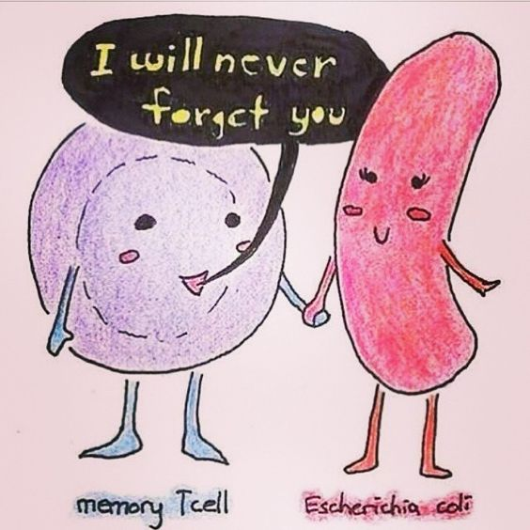
Read: Chapter 43: Immune System
Watch: Bozeman Science videos by Paul Anderson

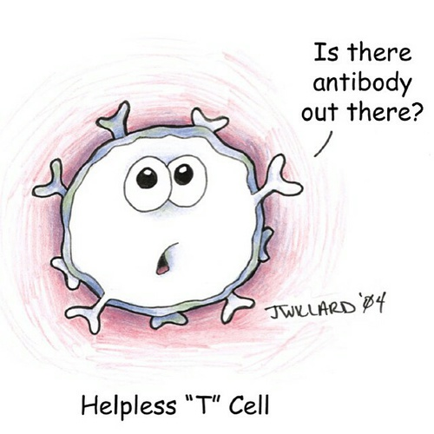
Practice:
- Quizlet: https://quizlet.com/_49svdu
- Test Prep for AP Biology Unit 8

Listen & Look:
Here are key terms you will come across as you begin to learn this material. Familiarize yourself with them! At the end of the topic, create a concept map connecting them to one another.
Key Terms
- Pathogens  - Defense mechanisms  - Nonspecific/innate immunity  - Specific/adaptive Immunity  - Passive Immunity | - Humoral Response  - B-Cells  - Plasma Cells  - Antigen  - Antibodies | - Cell Mediated Response  - T-Cells  - Cytotoxic T-cells  - Cytokines  - Perforin | - Plant defenses  - Invertebrate defenses

Focus Questions: Watch the Plant and Animal Defense Video and use your textbook and/or the video to help you answer these questions.
- How do invertebrates and animals without a specific immune system defend against invaders? Plants? HINT: Watch the first six minutes of the Plant and Animal Defenses to answer this question.
- Differentiate between a nonspecific and specific immune response.
- Compare and contrast the two specific mammalian immune responses, cell-mediated and humoral immunity in terms of their sites of action, action, and cells involved.
- Define antigens and antibodies and describe the relationship between them
- Describe the cell-mediated response, including a definition and role of cytotoxic T cells, antigens, and antibodies.
- Describe the humoral response, including a definition and role of B cells, antibodies, and antigens.
- Explain the role of helper T-cells in the immune system. How are they different from B-cells?
- Identify at least TWO different types of cellular communication present in the cell-mediated and/or humoral immune system of mammals and when/where these types of communication occur.
- Why is it that you don’t get the chickenpox, once you have already had it (Explain how and why the second exposure to an antigen is different than the first OR Explain how immunity is acquired during a vertebrate’s life cycle)? These are three different ways of asking the same question...can you identify the concept?
- If you are bitten by a venomous snake, what type of immunity are you given when you receive an anti-venom injection? When you received your hepatitis vaccination, what type of immunity are you given?
- Explain why vaccines are effective tools in preventing disease.
- How do invertebrate defenses differ from vertebrate defenses?

Focus questions modified from David Knufke, http://mrknuffke.net/ap-biology and Ruth Gleicher, https://sites.google.com/a/d219.org/gleicher/ap-biology

