Worksheet – Control Mechanism (lac & trp operons) Name:_________________________ # ____ Blk _____

1. Complete the comparison of the lac Operon and trp Operons as a means of gene regulation.

 | lac operon | trp operon
Regulates production of:
Number of genes and how they are controlled
What binds to the operator & when does this occur
High levels of what substance affects the operon how?

2. Why have genes under regulation?

3. What is the function of the promoter?

4. What is the function of the operator?

5. What happens if lactose levels are low? Put the following list in order (1-5).
RNA polymerase is blocked from transcribing the genes for the lactose metabolizing enzymes

When RNA polymerase binds to the promoter, it cannot get past the LacI repressor protein

The enzymes (B-galactosidae, B-galacosidae permease, and transacetylase) are not required by the cell due to low levels of lactose
Lactose does not bind to the repressor protein, LacI

LacI, a repressor protein, is bound to the operator, which follows the promoter

6. What happens if tryptophan levels are high? Put the following list in order (1-4).

The trp repressor-tryptophan complex can now bind to the operator of the trp operon

Tryptophan does not need to be produced by the trp operon

Tryptophan will bind to the repressor protein, changing its conformation

RNA Polymerase is blocked from transcribing the genes needed to synthesize tryptophan

7. What happens if lactose is present and glucose is scarce? Put the following list in order (1-7). Start with the repressor part first.

The three enzymes involved in the metabolism of lactose are transcribed and expressed

cAMP binds to CAP regulatory protein, causing it to bind to the promoter of the lac operon

The enzymes needed for lactose metabolism must be transcribed when lactose is present

cAMP levels increase because glucose is scarce (ATP is not being produced through cell respiration)

Lactose binds to the LacI repressor, changing LacI’s shape and making it fall off the operator

CAP binding causes RNA Polymerase to bind to the promoter (higher affinity) and transcribe the gene at a higher level than before
Now that LacI has been removed for the operator, RNA polymerase can proceed with transcription

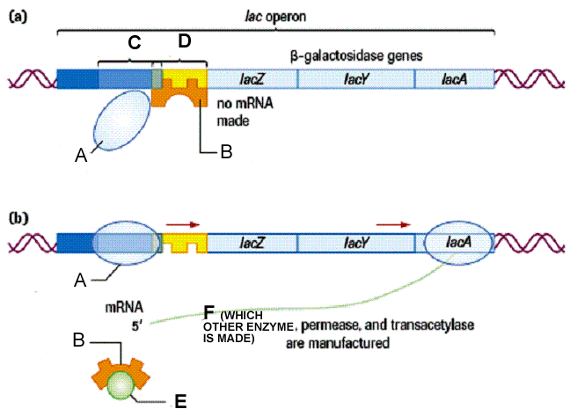8. Label the following diagram.

OMIT: Create a Playdoh model of the lac operon on a manila folder (so you can transport it). Be able to explain how it works when you show me your model. Be able to explain the following: positive regulation, negative regulation, repressible operon, inducible operon, operon, operator, repressor protein, promoter, corepressor, inducer

